Round Tours

Valid from 01st May 2014 to 31st October 2014

Content
Tour Name Page Number
- Sri Lanka Map 01 – 01
- Cultural Highlights (03 Days / 02 Nights Tour) 02 – 06
- Hill Country Tour (03 Days / 02 Nights Tour) 07 - 11
- Exotic Lanka (04 Days / 03 Nights Tour) 12 – 17
- Exotic Lanka Special (04 Days / 03 Nights Tour) 18 – 22
- Cultural Experience (05 Days / 04 Nights Tour) 23 – 28
- Explore the Paradise (05 Days / 04 Nights Tour) 29 – 34
- Culture and Nature (07 Days / 06 Nights Tour) 35 – 41
- Hotels utilized in tours 42 – 42
- Seasonal supplements 43 - 43
- General Terms and Conditions 44 – 44

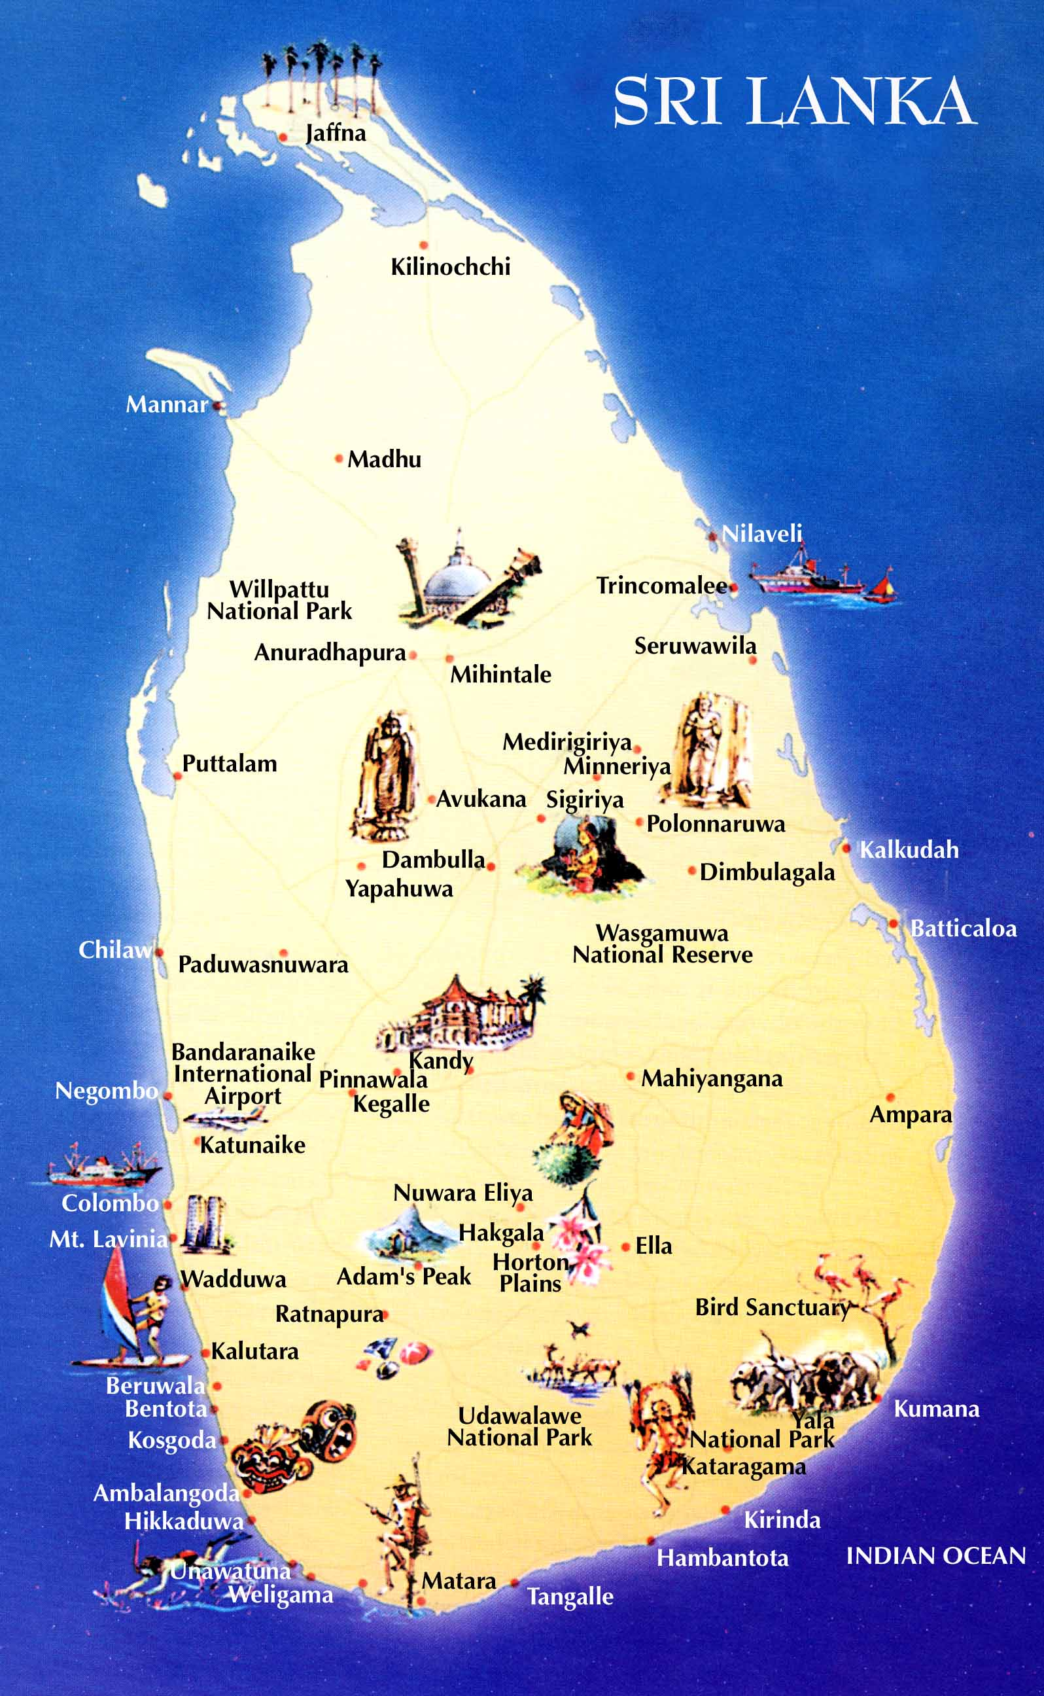

Programme : Cultural Highlights Tour
Duration : 3 Days / 2 Nights
Period/Dates : Summer 2014 (01st May ‘14 to 31st October ‘14)
______________________________________________________________________________

Tour Itinerary
DAY 01 : AIRPORT / KANDY

DAY 01 : AIRPORT /KANDY

DAY 01 : AIRPORT /KANDY

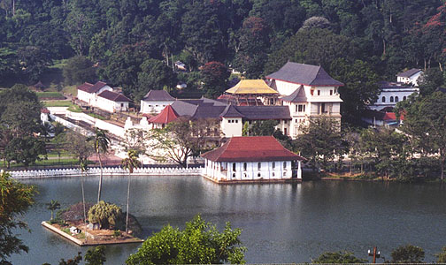

Arrival at Colombo International Airport where
you will be met & welcome by Aitken Spence representative or Tour Guide and transfer to Kandy.

Evening visit the Temple of the Tooth Relic in Kandy. Thereafter proceed to an auditorium to witness a cultural show

Dinner and overnight stay at the hotel in Kandy

DAY 02 : KANDY / SIGIRIYA / DAMBULLA / MATALE / KANDY

DAY 01 : AIRPORT /KANDY

DAY 01 : AIRPORT /KANDY

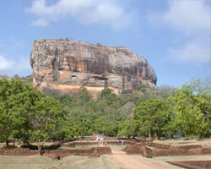
After breakfast proceed to Sigiriya and climb the 5th century Sigiriya rock fortress which is a world heritage site, built by King Kashyapa (477 - 495 AD )
The ‘Lion Rock' is a citadel of unusual beauty rising 200 meters from the scrub jungle. The rock was innermost stronghold of the 70 hectare fortified town. A moat, rampart, and extensive gardens including the renowned water gardens ring the base of the rock. Visit the World -renowned frescoes of 'Heavenly Maidens' of Sigiriya,
Which are in a sheltered pocket of the rock approached
by a spiral stairway. These frescoes are painted in earth pigments on plaster.
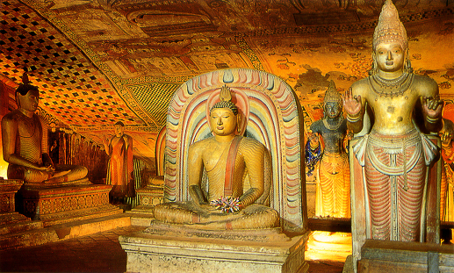
On completion return to Kandy. En route visit Dambulla Rock Cave Temple was built by king Walagambahu in the 1st century B.C. and it is a World Heritage Site. It is the most impressive of Sri Lanka's cave temples. The complex of five caves with over 2000 sq. meters of painted walls and ceilings is the largest area of paintings found in the world. It contains over 150 images of the Buddha of which the largest is the colossal figure of the Buddha carved out of rock and spanning 14 meters.

Thereafter visit a spice garden in Matale to see different spices for which Sri Lanka is famous for. Here, clients could see different spices and how some of these spices are grown and processed. Witness a Cookery demonstration.

Dinner and overnight stay at the hotel in Kandy

DAY 03 : KANDY / PERADENIYA / PINNAWALA / SELECTED BEACH RESORT

DAY 01 : AIRPORT /KANDY

DAY 01 : AIRPORT /KANDY

After breakfast proceed on city tour of Kandy. Kandy was the last capital of the Sri Lankan kings and is
a World Heritage Site. http://www.kandycity.org/index2.html The name "Kandy" conjures visions of splendor and magnificence. Many of the legends, traditions and folklore are still lovingly kept alive. Drive around the Kandy Lake built by the last Sinhala king, Sri Wickrama Rajasinghe in 1798. Visit the Kandy town and bazaar, the arts and crafts centre, a gem museum and a lapidary.

Thereafter visit The Royal Botanical Garden in Peradeniya. The botanical garden was first built as a Pleasure garden by a Sinhala king and was expanded by the British. It is 147 acres in extent and provides an amazing variety of trees, plants and flowers. http://www.kandycity.org/botanical.htm
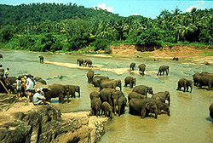
On completion transfer to Beach Hotel. En route visit Elephant Orphanage in Pinnawala, established in 1975, commenced with seven orphans. Today some of these orphans enjoy the fortune of seeing their Grand children born in the same location. The original objective of establishing the orphanage inclined more towards tourism,
but is soon became a conservation and educational centre. With the help of local and foreign elephant experts, Pinnawela started a scientific captive-breeding programme
for elephants. The free movement of the herd enhanced the chances for respective individuals of both
sexes to get together and mate. The nearby river played a dominant role in this regard, and in 1984, the first baby of Pinnawela was born. The success story of Pinnawela has drawn the attention of scientists from all over the world. A considerable number of books and research articles on Pinnawela have been published in several languages. The members of the Pinnawela herd have been filmed, videoed and photographed thousands of times by professionals. http://www.elephant.se/zoos/srilanka/pinnawela.htm.

Transfer from Pinnawala to Beach Resort up to Beruwala from South and Marawila from North.

-Tour End-

- Tour Category - Standard tour
 | 02 pax | 03 pax | 04 pax | 05-06 pax | 07-12 pax | Single Traveler
Accommodation on HB & Transportation with Russian speaking guide | 228.00 | 210.00 | 165.00 | 152.00 | 145.00 | 390.00
Entrance fees for sights | 81.00 | 81.00 | 81.00 | 81.00 | 81.00 | 81.00
Total package rate (Accommodation + Transportation + Entrance fees) | 309.00 | 291.00 | 246.00 | 233.00 | 226.00 | 471.00

Single Supplement | USD 31.00
Peak period supplement (16/07/14 – 31/07/14) on DBL sharing  Peak period supplement (16/07/14 – 31/07/14) on SGL room | USD 15.00  USD 25.00
Perahera period supplement (01/08/14 – 10/08/14) on DBL sharing  Perahera period supplement (01/08/14 – 10/08/14) on SGL room | USD 50.00  USD 85.00
Peak period supplement (11/08/14 – 31/08/14) on DBL sharing  Peak period supplement (11/08/14 – 31/08/14) on SGL room | USD 15.00  USD 25.00

- Tour Category – Superior tour
 | 02 pax | 03 pax | 04 pax | 05-06 pax | 07-12 pax | Single Traveler
Accommodation on HB & Transportation with Russian speaking guide | 256.00 | 220.00 | 175.00 | 162.00 | 155.00 | 567.00
Entrance fees for sights | 81.00 | 81.00 | 81.00 | 81.00 | 81.00 | 81.00
Total package rate (Accommodation + Transportation + Entrance fees) | 337.00 | 301.00 | 256.00 | 243.00 | 236.00 | 648.00

Single Supplement | USD 80.00
Perahera period supplement (01/08/14 – 10/08/14) on DBL sharing  Perahera period supplement (01/08/14 – 10/08/14) on SGL room | USD 40.00  USD 80.00

- Tour Category – Deluxe
 | 02 pax | 03 pax | 04 pax | 05-06 pax | 07-12 pax | Single Traveler
Accommodation on HB & Transportation with Russian speaking guide | 328.00 | 273.00 | 242.00 | 224.00 | 212.00 | 595.00
Entrance fees for sights | 81.00 | 81.00 | 81.00 | 81.00 | 81.00 | 81.00
Total package rate (Accommodation + Transportation + Entrance fees) | 409.00 | 354.00 | 323.00 | 305.00 | 293.00 | 676.00

Single Supplement | USD 90.00
Perahera period supplement (01/08/14 –10/08/14) on DBL sharing  Perahera period supplement (01/08/14 – 10/08/14) on SGL room | USD 70.00  USD 80.00
Peak period supplement (11/08/14 – 31/08/14) on DBL sharing  Peak period supplement (11/08/14 – 31/08/14) on SGL room | USD 20.00  USD 40.00

- Tour Category – Premium
 | 02 pax | 03 pax | 04 pax | 05-06 pax | 07-12 pax | Single Traveler
Accommodation on HB & Transportation with Russian speaking guide | 333.00 | 289.00 | 264.00 | 249.00 | 242.00 | 560.00
Entrance fees for sights | 81.00 | 81.00 | 81.00 | 81.00 | 81.00 | 81.00
Total package rate (Accommodation + Transportation + Entrance fees) | 414.00 | 370.00 | 345.00 | 330.00 | 323.00 | 641.00

Single Supplement | USD 85.00
Peak period supplement (16/07/14 – 31/07/14) on DBL sharing  Peak period supplement (16/07/14 – 31/07/14) on SGL room | USD 35.00  USD 60.00
Perahera period supplement (01/08/14 – 10/08/14) on DBL sharing  Perahera period supplement (01/08/14 – 10/08/14) on SGL room | USD 95.00  USD 180.00
Peak period supplement (11/08/14 – 31/08/14) on DBL sharing  Peak period supplement (11/08/14 – 31/08/14) on SGL room | USD 35.00  USD 60.00

Supplement for Beach stay transfer beyond Bentota
Bentota - Induruwa - USD 6.00 per person
Bentota - Ahungalla - USD 11.00 per person
Bentota - Hikkaduwa - USD 16.00 per person
Bentota - Galle - USD 22.00 per person
Bentota - Koggala - USD 24.00 per person
Bentota – Dickwella - USD 38.00 per person

Tricnomalee drop - USD 50.00 per person

The above prices include:
• Accommodation in standard rooms on Half Board basis for 2 nights from dinner on day 1 to breakfast on day 3 at hotels specified or of similar standard.
• Transportation by air-conditioned vehicle from pick up at airport to drop off at Beach Hotel - up to Bentota (from South) and Marawila (from North)
• Service of a Russian speaking National guide

Please note the Entrance fees for sights are shown separately. As per the clients’ choice, we can include it or exclude it from the package

Above prices does not include:
• Video Camera permits at Pinnawala Elephant Orphanage.
• Video Camera and Still Camera permits at the Temple of the Tooth Relic in Kandy.
• Lunch throughout the tour.
• Entrance fees to sites not specified above.
• Cost of beverage and expenses of a personal nature throughout the tour
• Tips and Porterage
• Any other services not specified above.

Programme : Hill Country Tour
Duration : 3 Days / 2 Nights
Period/Dates : Summer 2014 (01st May ‘14 to 31st October ‘14)
______________________________________________________________________________
Tour Itinerary
DAY 01 : AIRPORT / KANDY

DAY 01 : AIRPORT /KANDY

DAY 01 : AIRPORT /KANDY

Arrival at Colombo International Airport where
you will be met & welcome by Aitken Spence representative or Tour Guide and transfer to Kandy.

Afternoon proceed on city tour of Kandy. Kandy was the last capital of the Sri Lankan kings and is
a World Heritage Site. http://www.kandycity.org/index2.html The name "Kandy" conjures visions of splendor and magnificence. Many of the legends, traditions and folklore are still lovingly kept alive. Drive around the Kandy Lake built by the last Sinhala king, Sri Wickrama Rajasinghe in 1798. Visit the Kandy town and bazaar, the arts and crafts centre, a gem museum and a lapidary.

Thereafter visit The Royal Botanical Garden in Peradeniya. The botanical garden was first built as a Pleasure garden by a Sinhala king and was expanded by the British. It is 147 acres in extent and provides an amazing variety of trees, plants and flowers. http://www.kandycity.org/botanical.htm

Evening visit the Temple of the Tooth Relic in Kandy. Thereafter proceed to an auditorium to witness a cultural show

Dinner and overnight stay at the hotel in Kandy

DAY 02 : KANDY / PINNAWELA / NUWARAELIYA

DAY 01 : AIRPORT /KANDY

DAY 01 : AIRPORT /KANDY

After breakfast proceed to Nuwara Eliya.

En route visit Elephant Orphanage in Pinnawala, established in 1975, commenced with seven orphans. Today some of these orphans enjoy the fortune of seeing their Grand children born in the same location. The original objective of establishing the orphanage inclined more towards tourism,
but is soon became a conservation and educational centre. With the help of local and foreign elephant experts, Pinnawela started a scientific captive-breeding programme
for elephants. The free movement of the herd enhanced the chances for respective individuals of both
sexes to get together and mate. The nearby river played a dominant role in this regard, and in 1984, the first baby of Pinnawela was born. The success story of Pinnawela has drawn the attention of scientists from all over the world. A considerable number of books and research articles on Pinnawela have been published in several languages. The members of the Pinnawela herd have been filmed, videoed and photographed thousands of times by professionals. http://www.elephant.se/zoos/srilanka/pinnawela.htm.

Proceed to Nuwara Eliya.

Dinner and overnight stay at the hotel in Nuwara Eliya

DAY 03 : NUWARA ELIYA / KITULGALA / SELECTED BEACH RESORT

DAY 01 : AIRPORT /KANDY

DAY 01 : AIRPORT /KANDY

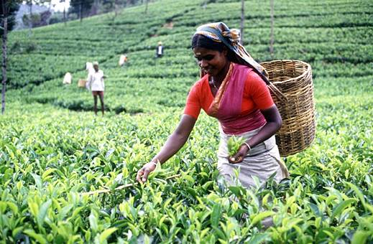
After breakfast visit Nuwara Eliya. Nuwara Eliya, because of its invigorating mountain climate and scenery, is Sri Lankas most popular hill resort. Nuwara Eliya is also the heart of Sri Lankas tea country producing a significant share of the world s best tea. Sri Lanka s highest mountain Pidurutalagala (8282 feet) is located here. Nuwara Eliya also has one of the finest 18 hole golf courses in South Asia. On completion
transfer to Beach resort via Kitulgala. The Kelani River (the broadest river in Sri Lanka ) flowing through
Kitulgala was the main location where the Oscar winning movie “Bridge on the River Kwai” was filmed. On the hill above this town, a prehistoric cave was recently discovered containing large middens of shells from some unknown civilization.

Adventure - Optional excursion in Kitulgala
River rafting for 45 minutes
Price : - 2pax - US$ 45.00 (per person)
Above 2pax - US$ 35.00 (per person)

* Discount of US$ 5.00, if pre-booked by clients at the time of the first booking.

Transfer from Nuwara Eliya to Beach Resort up to Beruwala from South and Marawila from North.

-Tour End-

- Tour Category - Standard tour
 | 02 pax | 03 pax | 04 pax | 05-06 pax | 07-12 pax | Single Traveler
Accommodation on HB & Transportation with Russian speaking guide | 261.00 | 213.00 | 169.00 | 164.00 | 152.00 | 465.00
Entrance fees for sights | 37.00 | 37.00 | 37.00 | 37.00 | 37.00 | 37.00
Total package rate (Accommodation + Transportation + Entrance fees) | 298.00 | 250.00 | 206.00 | 201.00 | 194.00 | 502.00

Single Supplement | USD 46.00
Peak period supplement (16/07/14 – 30/07/14) on DBL sharing  Peak period supplement (16/07/14 – 30/07/14) on SGL room | USD 15.00  USD 25.00

Perahera period supplement (01/08/14 – 10/08/14) on DBL sharing  Perahera period supplement (01/08/14 – 10/08/14) on SGL room | USD 50.00  USD 95.00
Peak period supplement (11/08/14 – 31/08/14) on DBL sharing  Peak period supplement (11/08/14 – 31/08/14) on SGL room | USD 20.00  USD 35.00

- Tour Category – Superior tour
 | 02 pax | 03 pax | 04 pax | 05-06 pax | 07-12 pax | Single Traveler
Accommodation on HB & Transportation with Russian speaking guide | 280.00 | 232.00 | 205.00 | 189.00 | 187.00 | 497.00
Entrance fees for sights | 37.00 | 37.00 | 37.00 | 37.00 | 37.00 | 37.00
Total package rate (Accommodation + Transportation + Entrance fees) | 317.00 | 269.00 | 242.00 | 226.00 | 224.00 | 534.00

Single Supplement | USD 65.00
Peak period supplement (01/08/14 – 10/08/14) on DBL sharing  Peak period supplement (01/08/14 – 10/08/14) on SGL room | USD 20.00  USD 40.00

- Tour Category – Deluxe Tour
 | 02 pax | 03 pax | 04 pax | 05-06 pax | 07-12 pax | Single Traveler
Accommodation on HB & Transportation with Russian speaking guide | 307.00 | 257.00 | 229.00 | 212.00 | 208.00 | 557.00
Entrance fees for sights | 37.00 | 37.00 | 37.00 | 37.00 | 37.00 | 37.00
Total package rate (Accommodation + Transportation + Entrance fees) | 344.00 | 294.00 | 266.00 | 249.00 | 245.00 | 594.00

Single Supplement | USD 90.00
Perahera period supplement (01/08/14 –10/08/14) on DBL sharing  Perahera period supplement (01/08/14 – 10/08/14) on SGL room | USD 35.00  USD 40.00
Peak period supplement (11/08/14 – 31/08/14) on DBL sharing  Peak period supplement (11/08/14 – 31/08/14) on SGL room | USD 10.00  USD 20.00

- Tour Category – Premium Tour
 | 02 pax | 03 pax | 04 pax | 05-06 pax | 07-12 pax | Single Traveler
Accommodation on HB & Transportation with Russian speaking guide | 429.00 | 348.00 | 313.00 | 292.00 | 286.00 | 715.00
Entrance fees for sights | 37.00 | 37.00 | 37.00 | 37.00 | 37.00 | 37.00
Total package rate (Accommodation + Transportation + Entrance fees) | 466.00 | 385.00 | 350.00 | 329.00 | 323.00 | 752.00

Single Supplement | USD 85.00
Peak period supplement (16/07/14 – 31/07/14) on DBL sharing  Peak period supplement (16/07/14 – 31/07/14) on SGL room | USD 35.00  USD 60.00
Perahera period supplement (01/08/14 – 10/08/14) on DBL sharing  Peak period supplement (01/08/14 – 10/08/14) on SGL room | USD 65.00  USD 120.00
Peak period supplement (11/08/14 – 31/08/14) on DBL sharing  Peak period supplement (11/08/14 – 31/08/14) on SGL room | USD 35.00  USD 60.00

Supplement for Beach stay transfer beyond Bentota
Bentota - Induruwa - USD 6.00 per person
Bentota - Ahungalla - USD 11.00 per person
Bentota - Hikkaduwa - USD 16.00 per person
Bentota - Galle - USD 22.00 per person
Bentota - Koggala - USD 24.00 per person
Bentota – Dickwella - USD 38.00 per person

Tricnomalee drop - USD 75.00 per person

The above prices include:
• Accommodation in standard rooms on Half Board basis for 2 nights from dinner on day 1 to breakfast on day 3 at hotels specified or of similar standard.
• Transportation by air-conditioned vehicle from pick up at airport to drop off at Beach Hotel - up to Bentota (from South) and Marawila (from North)
• Service of a Russian speaking National guide

Please note the Entrance fees for sights are shown separately. As per the clients’ choice, we can include it or exclude it from the package

Above prices does not include:
• Video Camera permits at Pinnawala Elephant Orphanage.
• Video Camera and Still Camera permits at the Temple of the Tooth Relic in Kandy.
• Lunch throughout the tour.
• Entrance fees to sites not specified above.
• Cost of beverage and expenses of a personal nature throughout the tour
• Tips and Porterage
• Any other services not specified above.

Programme : Exotic Lanka Tour
Duration : 4 Days / 3 Nights.
Period/Dates : Summer 2014 (01st May ‘14 to 31st October ‘14)
_________________________________________________________________________________________

Tour Itinerary
DAY 01 : AIRPORT / GIRITALE OR DAMBULLA OR HABARANA OR KANDALAMA

DAY 01 : AIRPORT /KANDY

DAY 01 : AIRPORT /KANDY

Arrival at Colombo International Airport where you will be met & welcome by out representative
or Tour Guide and transfer to area of choice.

Dinner and overnight stay at hotel as per selected category.
DAY 02 : GIRITALE – KANDALAMA AREA / SIGIRIYA / POLONNARUWA

DAY 01 : AIRPORT /KANDY

DAY 01 : AIRPORT /KANDY

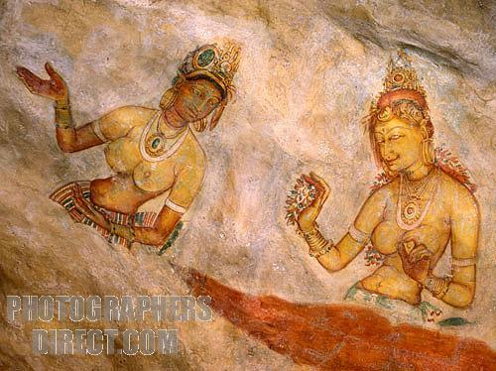
After breakfast proceed to Sigiriya and climb the 5th century Sigiriya rock fortress which is a world heritage site, built by King Kashyapa (477 - 495 AD). The 'Lion Rock' is a citadel of unusual beauty rising 200 meters from the scrub jungle. The rock was innermost stronghold of the 70 hectare fortified town. A moat, rampart, and extensive gardens including the renowned
water gardens ring the base of the rock. Visit the world-renowned frescoes of 'Heavenly Maidens' of Sigiriya, which are in a sheltered pocket of the rock approached by a spiral stairway. These frescoes are
painted in earth pigments on plaster.

Return to the hotel or do an optional excursion in the afternoon.

Culture - Optional excursion to Polonnaruwa http://www.worldheritagesite.org/sites/site201.html
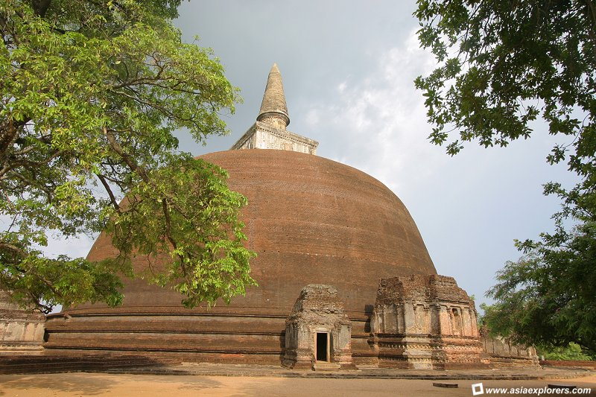
Visit Polonnaruwa, which was the 2nd capital city of Sri
Lanka, built in the 11th and 12th centuries AD, and which is a world heritage site.. Here you can see the ruins of the Royal Palace, the Gal Viharaya where 4 splendid statues of the Buddha in 'Upright', 'Sedentary' and 'Recumbent' postures carved out of rock could be seen, the Audience Hall, the Lotus Bath, the statue of king Parakramabahu, and the Parakrama S amudraya, a lake built by King Parakramabahu the great. There are also monuments of famous places of worship such as the Shiva Temple, the Lankathilake, the Watadage, the Galpotha, the Kiri Vehera and the
remains of a former Temple of the Tooth Relic. After excursion, return to the hotel

Price : - 2pax - US$ 60.00 (per person)
Above 2pax - US$ 50.00 (per person)

* Discount of US$ 5.00, if pre-booked by clients at the time of the first booking.

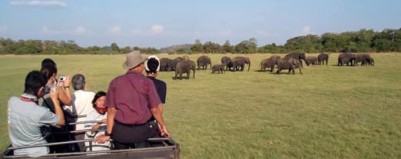
Adventure - Optional excursion to a National Park for Safari
Do a safari of the Minneriya or Kaudulla or Eco National Park by jeep. The extent of the National Park is about 8,889 hectares. There are wet -lands in this National Park, which have international importance, animal and plant species, which are plenty in dry zone, are found in this park. Wild elephants , various amphibians, local and immigrant bird species are plenty in this park. About 160 species of birds, 09 amphibians, 25 reptile species, 26 fish species and more than 78 butterfly species have been found in this area. There are Bamboo trees, which are rare in other parks, and wild Elephants can be seen conveniently. The significant feature is that these elephants can be seen going closer to them. After excursion, return to the hotel

Price : - 2pax - US$ 70.00 (per person)
Above 2pax - US$ 60.00 (per person)
* Discount of US$ 5.00, if pre-booked by clients at the time of the first booking.

Dinner and overnight stay at hotel as per selected category

DAY 03 : GIRITALE – KANDALAMA AREA / DAMBULLA / MATALE / KANDY

DAY 01 : AIRPORT /KANDY

DAY 01 : AIRPORT /KANDY

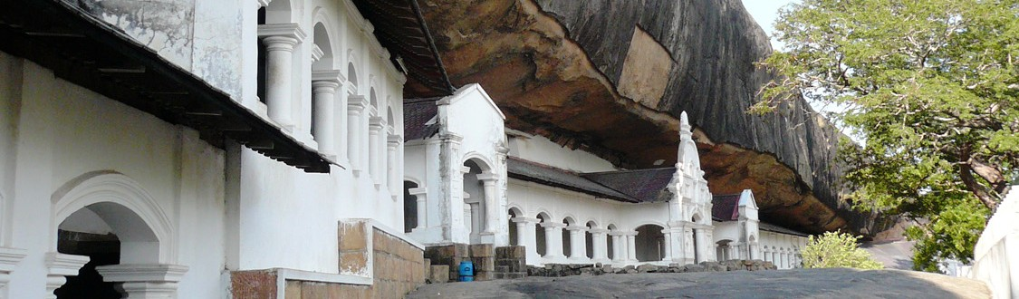
After breakfast leave for Kandy. En route
visit Dambulla Rock Cave Temple was built
by king Walagambahu in the 1st century B.C.
and it is a World Heritage Site. It is the most
impressive of Sri Lanka's cave temples. The
complex of five caves with over 2000 sq.
meters of painted walls and ceilings is the
largest area of paintings found in the world.
It contains over 150 images of the Buddha
of which the largest is the colossal figure of
the Buddha carved out of rock and spanning
14 metres.

Thereafter visit a spice garden in Matale to see different spices for which Sri Lanka is famous for. Here, clients could see different spices and how some of these spices are grown and processed. Witness a Cookery demonstration.

Proceed to Kandy and check in at hotel. Afternoon proceed on a city tour of Kandy. Kandy was the last capital of the Sri Lankan kings and is a World Heritage Site. http://www.kandycity.org/index2.html. The name "Kandy" conjures visions of splendour and magnificence. Many of the legends, traditions and folklore are still lovingly kept alive. Drive around the Kandy Lake built by the last Sinhala king, Sri Wickrama Rajasinghe in 1798. Visit the Kandy town and bazaar, the arts and crafts centre, a gem museum and a lapidary. Evening visit the Temple of the Tooth Relic in Kandy. Thereafter proceed to an auditorium to witness a cultural show.

Dinner and overnight stay at hotel in Kandy

DAY 04 : KANDY / PERADENIYA / PINNAWLA / SELECTED BEACH RESORT

DAY 01 : AIRPORT /KANDY

DAY 01 : AIRPORT /KANDY

After breakfast visit The Royal Botanical Garden in Peradeniya, which was first built as a pleasure garden by a Sinhala king and was expanded by the British. http://www.kandycity.org/botanical.htm. It is 147 acres in extent and provides an amazing variety of trees, plants and flowers.

On completion leave for your beach resort. En route visit. The Elephant Orphange in Pinnawala, established in 1975, commenced with seven orphans. http://www.elephant.se/zoos/srilanka/pinnawela.htm. Today
some of these orphans enjoy the fortune of seeing their grandchildren born in the same location. The original objective of establishing the orphanage inclined more towards tourism, but is soon became a conservation and educational centre. With the help of local and foreign elephant experts, Pinnawela started a scientific captive-breeding programme for elephants. The free movement of the herd enhanced the chances for respective individuals of both sexes to get together and mate. The nearby river played a dominant role in this regard, and in 1984, the first baby of Pinnawela was born. The success story of Pinnawela has drawn the attention of scientists from all over the world. A considerable number of books and research articles on Pinnawela have been published in several languages. The members of the Pinnawela herd have been filmed, videoed and photographed thousands of times by professionals.

Transfer from Pinnawala to Beach Hotel up to Beruwala from South and Marawila from North.

-Tour End-

- Tour Category - Standard tour
 | 02 pax | 03 pax | 04 pax | 05-06 pax | 07-12 pax | Single Traveler
Accommodation on HB & Transportation with Russian speaking guide | 312.00 | 264.00 | 238.00 | 222.00 | 213.00 | 564.00
Entrance fees for sights | 81.00 | 81.00 | 81.00 | 81.00 | 81.00 | 81.00
Total package rate (Accommodation + Transportation + Entrance fees) | 393.00 | 345.00 | 319.00 | 303.00 | 294.00 | 645.00

Single Supplement | USD 100.00
Peak period supplement (16/07/14 – 31/07/14) on DBL sharing  Peak period supplement (16/07/14 – 31/07/14) on SGL room | USD 15.00  USD 25.00
Perahera period supplement (01/08/14 – 10/08/14) on DBL sharing  Perahera period supplement (01/08/13 – 10/08/14) on SGL room | USD 50.00  USD 95.00
Peak period supplement (11/08/14 – 31/08/14) on DBL sharing  Peak period supplement (11/08/13 – 31/08/14) on SGL room | USD 15.00  USD 25.00

- Tour Category – Superior tour
 | 02 pax | 03 pax | 04 pax | 05-06 pax | 07-12 pax | Single Traveller
Accommodation on HB & Transportation with Russian speaking guide | 354.00 | 302.00 | 274.00 | 257.00 | 242.00 | 648.00
Entrance fees for sights | 81.00 | 81.00 | 81.00 | 81.00 | 81.00 | 81.00
Total package rate (Accommodation + Transportation + Entrance fees) | 435.00 | 383.00 | 355.00 | 338.00 | 323.00 | 729.00

Single Supplement | USD 130.00
Perahera period supplement (01/08/14 – 10/08/14) on DBL sharing  Perahera period supplement (01/08/14 – 10/08/14) on SGL room | USD 20.00  USD 40.00

- Tour Category – Deluxe Tour
 | 02 pax | 03 pax | 04 pax | 05-06 pax | 07-12 pax | Single Traveler
Accommodation on HB & Transportation with Russian speaking guide | 445.00 | 367.00 | 328.00 | 305.00 | 294.00 | 814.00
Entrance fees for sights | 81.00 | 81.00 | 81.00 | 81.00 | 81.00 | 81.00
Total package rate (Accommodation + Transportation + Entrance fees) | 526.00 | 448.00 | 409.00 | 386.00 | 375.00 | 895.00

Single Supplement | USD 140.00
Perahera period supplement (01/08/14 –10/08/14) on DBL sharing  Perahera period supplement (01/08/14 – 10/08/14) on SGL room | USD 30.00  USD 60.00
Peak period supplement (11/08/14 – 31/08/14) on DBL sharing  Peak period supplement (11/08/14 – 31/08/14) on SGL room | USD 10.00  USD 20.00

- Tour Category – Premium tour
 | 02 pax | 03 pax | 04 pax | 05-06 pax | 07-12 pax | Single Traveler
Accommodation on HB & Transportation with Russian speaking guide | 460.00 | 402.00 | 369.00 | 350.00 | 344.00 | 824.00
Entrance fees for sights | 81.00 | 81.00 | 81.00 | 81.00 | 81.00 | 81.00
Total package rate (Accommodation + Transportation + Entrance fees) | 541.00 | 483.00 | 450.00 | 431.00 | 425.00 | 905.00

Single Supplement | USD 145.00
Peak period supplement (16/07/14 – 20/07/14) on DBL sharing  Peak period supplement (16/07/14 – 20/07/14) on SGL room | USD 20.00  USD 30.00
Peak period supplement (21/07/14 – 31/07/14) on DBL sharing  Peak period supplement (21/07/14 – 31/07/14) on SGL room | USD 30.00  USD 50.00
Perahera period supplement (01/08/14 – 10/08/14) on DBL sharing  Perahera period supplement (01/08/14 – 10/08/14) on SGL room | USD 60.00  USD 110.00
Peak period supplement (11/08/14 – 31/08/14) on DBL sharing  Peak period supplement (11/08/13 – 31/08/14) on SGL room | USD 30.00  USD 50.00

Supplement for Beach stay transfer beyond Bentota
Bentota - Induruwa - USD 6.00 per person
Bentota - Ahungalla - USD 11.00 per person
Bentota - Hikkaduwa - USD 16.00 per person
Bentota - Galle - USD 22.00 per person
Bentota - Koggala - USD 24.00 per person
Bentota – Dickwella - USD 38.00 per person

Tricnomalee drop - USD 40.00 per person

The above prices include:
- Accommodation in standard rooms on half board basis for 3 nights from dinner on day 1 to breakfast on day 4 at hotels specified or of similar standard.
- Transportation by air-conditioned vehicle from pick up at airport to drop off at Beach Hotel – up to Bentota (South) and Marawila (North).
- Services of a Russian Speaking National Guide.

Please note the Entrance fees for sights are shown separately. As per the clients’ choice, we can include it or exclude it from the package

Above prices does not include:
- Video Camera permits at Pinnawala Elephant Orphanage.
- Video Camera and Still Camera permits at the Temple of the Tooth Relic in Kandy.
- Lunch throughout the tour.
- Entrance fees to sites not specified above.
- Optional Excursions
- Cost of beverage and expenses of a personal nature throughout the tour.
- Tips and Porterage
- Any other services not specified above.

Programme : Exotic Lanka Special
Duration : 4 Days / 3 Nights.
Period/Dates : Summer 2014 (01st May ‘14 to 31st October ‘14)
__________________________________________________________________

Tour Itinerary
DAY 01 : AIRPORT / COLOMBO

DAY 01 : AIRPORT /KANDY

DAY 01 : AIRPORT /KANDY

Arrival at Colombo International Airport where you will be met & welcome by our representative
or Tour Guide and transfer to Colombo. Check in at hotel.

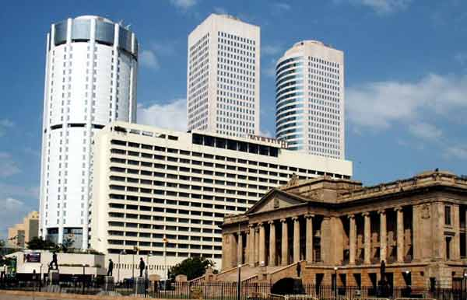
Afternoon proceed on at city tour of Colombo. In the afternoon, do a city tour of Colombo. Colombo like many capital cities in developing countries is fast changing its face. Almost overnight, skyscrapers arise from where old buildings once stood.Yet in some parts, the old world charm is retained. For example, there is a 100-year-old clock tower and several British built colonial buildings. Other places of interest are the Pettah bazaar – where one can shop for bargain, a Hindu and a Buddhist temple, residential areas where you find the
stately homes of the affluent, the Bandaranaike Memorial International Conference Hall ( BMICH ) an outright gift to Sri Lanka from the People’s Republic of China.

Dinner and overnight stay at hotel in Colombo.

DAY 02 : COLOMBO / PINNAWALA / SIGIRIYA / GIRITATLE – KANDALAMA AREA

DAY 01 : AIRPORT /KANDY

DAY 01 : AIRPORT /KANDY

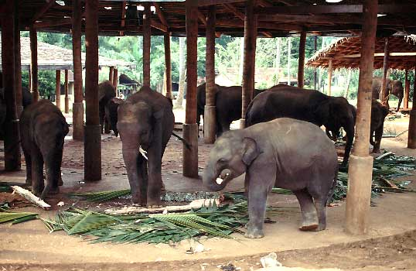
After breakfast proceed visit The Elephant Orpanage
In Pinnawala, established in 1975,commenced with seven
orphans. http://www.elephant.se/zoos/srilanka/pinnawela.htm
Today some of these orphans enjoy the fortune of seeing
their grandchildren born in the same location. The original
objective of establishing the orphanage inclined more
towards tourism, but is soon became a conservation
and educational centre. With help of local and foreign
elephant experts, Pinnawela started a scientific captive
breeding programme for elephants. The free movement
of herd enhanced the chances for respective individuals
of both sexes to get together and mate. The nearby river played a dominant role in this regard, and in
1984, the first baby of Pinnawela was born. The success story of Pinnawela has rawn he attention of scientists from all over the world. A considerable number of books and research articles on Pinnawela
have been published in several languages. The members of the Pinnawela herd have been filmed, videoed and photographed thousands of times by professionals.

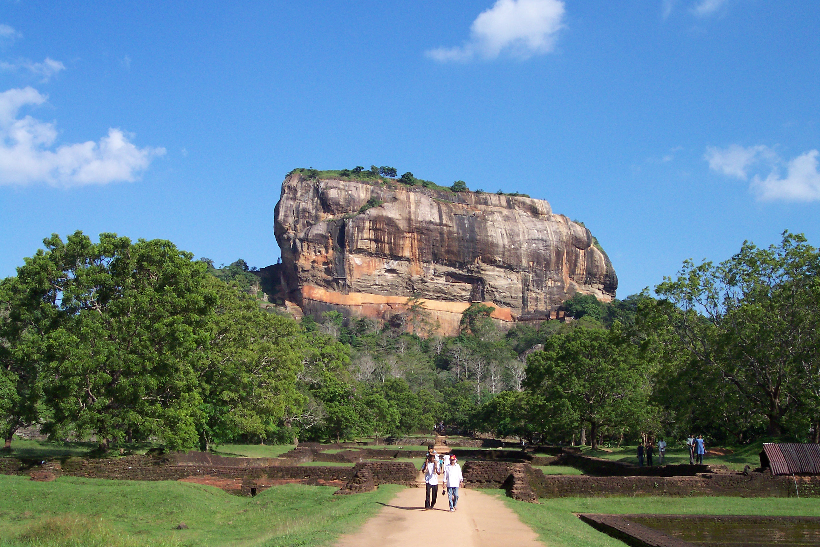
On completion proceed to Sigiriya and climb the 5th century Sigiriya rock fortress which is a world heritage site, built by King Kashyapa. The ‘Lion Rock’ is a citadel of unusual beauty rising 200 meters from the scrub jungle. The rock was the innermost stronghold of the 70 hectare fortified town. A moat, rampart, and extensive gardens
including the renowned water gardens ring the base of the rock. Visit the world renowned frescoes of the ‘Heavenly Maidens’ o f Sigiriya,which are in a sheltered pocket of the rock approached by a spiral stairway. The frescoes are painted in earth pigments on plaster.

Dinner and overnight stay at hotel as per selected category.

DAY 03 : GIRITALE – KANDALAMA AREA / DAMBULLA / MATALE / KANDY

DAY 01 : AIRPORT /KANDY

DAY 01 : AIRPORT /KANDY

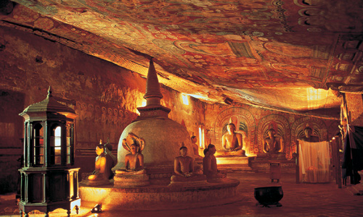
After breakfast leave for Kandy. En route visit Dambulla Rock Cave Temple which was built by king Walagambahu in the 1st century B.C. and it is a World Heritage Site. It is the most impressive of Sri Lanka’s cave temples. The complex of five caves with over 2000 sq. metres of painted walls and ceilings is the largest area of paintings found in the world. It contains
over 150 images of the Buddha of which the largest
is the colossal figure of the Buddha carved out of rock
and spanning 14 meters.

Visit a spice garden in Matale to see different spices for which Sri Lanka is famous for. Here, clients could see different spices and how some of these spices are grown and processed. Witness a Cookery demonstration. Kandy was the last capital of the Sri Lankan kings and is a World Heritage Site
.
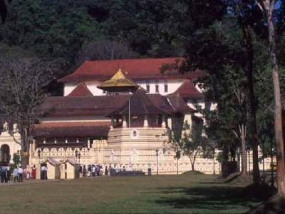
The name Kandy conjures visions of Splendor and magnificence. http://www.kandycity.org/index2.html. Many of the legends, traditions and folklore are still lovingly kept alive. Drive around the Kandy Lake built by the last Sinhala king, Sri Wickrama Rajasinghe in 1798. Visit the Kandy town and bazaar, the arts and crafts centre, a gem museum and a lapidary. Also visit the Temple of the Tooth Relic in Kandy. http://www.sridaladamaligawa.lk/. Thereafter proceed to an auditorium to witness a cultural show.

Dinner and overnight stay at hotel in Kandy
DAY 04 : KANDY / PERADENIYA / SELECTED BEACH RESORT

DAY 01 : AIRPORT /KANDY

DAY 01 : AIRPORT /KANDY

Breakfast at the hotel. Visit The Royal Botanical Garden in Peradeniya which was first built as a pleasure garden by a Sinhala king and was expanded by the British. http://www.kandycity.org/botanical.htm. It is 147 acres in extent and provides an amazing variety of trees, plants and flowers.

Transfer from Peradeniya to Beach Hotel up to Bentota from South and Marawila from North.

-Tour End-

- Tour Category - Standard tour
 | 02 pax | 03 pax | 04 pax | 05-06 pax | 07-12 pax | Single Traveller
Accommodation on HB & Transportation with Russian speaking guide | 332.00 | 279.00 | 249.00 | 231.00 | 222.00 | 587.00
Entrance fees for sights | 81.00 | 81.00 | 81.00 | 81.00 | 81.00 | 81.00
Total package rate (Accommodation + Transportation + Entrance fees) | 413.00 | 360.00 | 330.00 | 312.00 | 303.00 | 659.00

Single Supplement | USD 81.00
Peak period supplement (16/07/14 – 31/07/14) on DBL sharing  Peak period supplement (16/07/14 – 31/07/14) on SGL room | USD 15.00  USD 25.00
Perahera period supplement (01/08/14 – 10/08/14) on DBL sharing  Perahera period supplement (01/08/13 – 10/08/14) on SGL room | USD 50.00  USD 95.00
Peak period supplement (11/08/14 – 31/08/14) on DBL sharing  Peak period supplement (11/08/14 – 31/08/14) on SGL room | USD 15.00  USD 25.00

- Tour Category – Superior tour
 | 02 pax | 03 pax | 04 pax | 05-06 pax | 07-12 pax | Single Traveller
Accommodation on HB & Transportation with Russian speaking guide | 368.00 | 313.00 | 282.00 | 263.00 | 258.00 | 666.00
Entrance fees for sights | 81.00 | 81.00 | 81.00 | 81.00 | 81.00 | 81.00
Total package rate (Accommodation + Transportation + Entrance fees) | 449.00 | 394.00 | 363.00 | 344.00 | 339.00 | 747.00

Single Supplement | USD 120.00
Perahera period supplement (01/08/14 – 10/08/14) on DBL sharing  Perahera period supplement (01/08/14 – 10/08/14) on SGL room | USD 20.00  USD 40.00

- Tour Category – Deluxe Tour
 | 02 pax | 03 pax | 04 pax | 05-06 pax | 07-12 pax | Single Traveler
Accommodation on HB & Transportation with Russian speaking guide | 432.00 | 366.00 | 329.00 | 307.00 | 294.00 | 773.00
Entrance fees for sights | 81.00 | 81.00 | 81.00 | 81.00 | 81.00 | 81.00
Total package rate (Accommodation + Transportation + Entrance fees) | 479.00 | 419.00 | 384.00 | 364.00 | 369.00 | 799.00

Single Supplement | USD 128.00
Perahera period supplement (01/08/14 –10/08/14) on DBL sharing  Perahera period supplement (01/08/14 – 10/08/14) on SGL room | USD 30.00  USD 60.00
Peak period supplement (11/08/14 – 31/08/14) on DBL sharing  Peak period supplement (11/08/14 – 31/08/14) on SGL room | USD 10.00  USD 20.00

- Tour Category – Premium tour
 | 02 pax | 03 pax | 04 pax | 05-06 pax | 07-12 pax | Single Traveler
Accommodation on HB & Transportation with Russian speaking guide | 490.00 | 425.00 | 389.00 | 367.00 | 355.00 | 869.00
Entrance fees for sights | 81.00 | 81.00 | 81.00 | 81.00 | 81.00 | 81.00
Total package rate (Accommodation + Transportation + Entrance fees) | 571.00 | 506.00 | 470.00 | 448.00 | 436.00 | 950.00

Single Supplement | USD 170.00
Peak period supplement (16/07/14 – 20/07/14) on DBL sharing  Peak period supplement (16/07/14 – 20/07/14) on SGL room | USD 20.00  USD 30.00
Peak period supplement (21/07/14 – 31/07/14) on DBL sharing  Peak period supplement (21/07/14 – 31/07/14) on SGL room | USD 30.00  USD 50.00
Perahera period supplement (01/08/14 – 10/08/14) on DBL sharing  Peak period supplement (01/08/14 – 10/08/14) on SGL room | USD 60.00  USD 110.00
Peak period supplement (11/08/14 – 31/08/14) on DBL sharing  Peak period supplement (11/08/14 – 31/08/14) on SGL room | USD 30.00  USD 50.00

Supplement for Beach stay transfer beyond Bentota

Bentota - Induruwa - USD 6.00 per person
Bentota - Ahungalla - USD 11.00 per person
Bentota - Hikkaduwa - USD 16.00 per person
Bentota - Galle - USD 22.00 per person
Bentota - Koggala - USD 24.00 per person
Bentota – Dickwella - USD 38.00 per person

Tricnomalee drop - USD 40.00 per person

The above prices include:
- Accommodation in standard rooms on half board basis for 3 nights from dinner on day 1 to breakfast on day 4 at hotels specified or of similar standard.
- Transportation by air-conditioned vehicle from pick up at airport to drop off at Beach Hotel - up to Bentota (South) and Marawila (North).
- Service of a Russian Speaking National Guide.

Please note the Entrance fees for sights are shown separately. As per the clients’ choice, we can include it or exclude it from the package

Above prices does not include:
- Video Camera permits at Pinnawala Elephant Orphanage.
- Video Camera and Still Camera permits at the Temple of the Tooth Relic in Kandy.
- Lunch throughout the tour.
- Entrance fees to sites not specified above.
- Cost of beverage & expenses of a personal nature throughout the tour.
- Tips and Porterage
- Any other services not specified above.

Programme : Cultural Experience
Duration : 5 Days / 4 Nights.
Period/Dates : Summer 2014 (01st May ‘14 to 31st October ‘14)
______________________________________________________________________________

Tour Itinerary
DAY 01 : AIRPORT / GIRITALE OR DAMBULLA OR HABARANA OR KANDALAMA

DAY 01 : AIRPORT /KANDY

DAY 01 : AIRPORT /KANDY

Arrival at Colombo International Airport where you will be met & welcome by our representative
or Tour Guide and transfer to Dambulla. Check in at hotel.

Dinner & overnight stay at hotel as per selected category

DAY 02 : GIRITALE – KANDALAMA AREA / SIGIRIYA / GIRITALE – KANDALAMA AREA

DAY 01 : AIRPORT /KANDY

DAY 01 : AIRPORT /KANDY

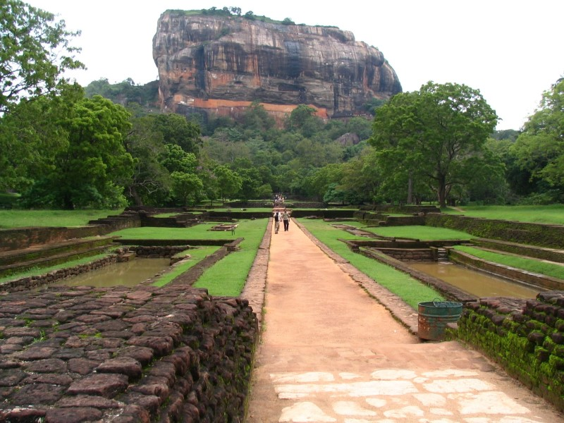
Breakfast at the hotel. Proceed to Sigiriya and climb the 5th century Sigiriya rock fortress which is a world heritage site, built by King Kashyapa (477-495 AD). The 'Lion Rock' is a citadel of unusual beauty rising 200 meters from the scrub jungle. The rock was the innermost stronghold of the 70 hectare fortified town. A moat, rampart, and extensive gardens including the renowned water gardens ring the base of the rock.
Visit the world-renowned frescoes of the 'Heavenly Maidens' of Sigiriya, which are in a sheltered pocket
of the rock approached by a spiral stairway. These frescoes are painted in earth pigments on plaster.

Return to the hotel or do an optional excursion in the afternoon.

Culture - Optional excursion to Polonnaruwa
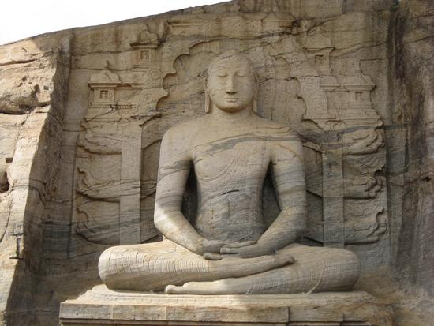
Visit Polonnaruwa, which was the 2nd capital city of Sri
Lanka, built in the 11th and 12th centuries AD, and which is a world heritage site. Here you can see the ruins of the Royal Palace, the Gal Viharaya where 4 splendid statues of the Buddha in 'Upright', 'Sedentary' and 'Recumbent' postures carved out of rock could be seen, the Audience Hall, the Lotus Bath, the statue of king Parakramabahu,
and the Parakrama Samudraya a lake built by King Parakramabahu the great. There are also monuments of famous places of worship such as the Shiva Temple, the Lankathilake, the Watadage, the Galpotha, the Kiri Vehera and the remains of a former Temple of the Tooth Relic. After excursion, return to the hotel

Price : - 2pax - US$ 60.00 (per person)
Above 2pax - US$ 50.00 (per person)

* Discount of US$ 5.00, if pre-booked by clients at the time of the first booking.

Adventure - Optional excursion to a National Park for Safari

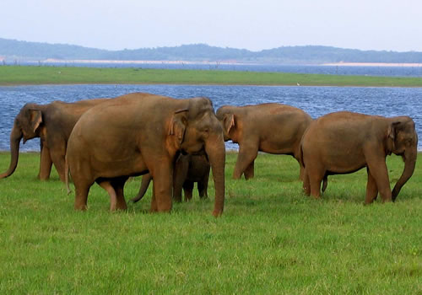
Do a safari of the Minneriya OR Kaudulla OR Eco National Park by jeep. The extent of the National Park is about 8,889 hectares. There are wet - lands in this National Park, which have international importance, animal and plant species which are plenty in dry zone, are found in this park. Wild elephants, various amphibians, local and immigrant bird species are plenty in his park. About 160 species of birds, 09
amphibians, 25 reptile species, 26 fish species and more
than 78 butterfly species have been found in this area. There are bamboo trees, which are rare in other parks,
and wild elephants can be seen conveniently. The significant feature is that these elephants can be
seen going closer to them. After excursion, return to the hotel

Price : - 2pax - US$ 70.00 (per person)
Above 2pax - US$ 60.00 (per person)

* Discount of US$ 5.00, if pre-booked by clients at the time of the first booking.

Dinner & overnight stay at hotel as per selected category

DAY 03 : GIRITALE – KANDALAMA AREA / DAMBULLA / MATALE / KANDY

DAY 01 : AIRPORT /KANDY

DAY 01 : AIRPORT /KANDY

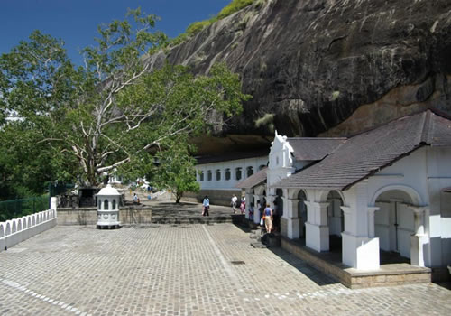
After breakfast leave for Kandy. En route visit Dambulla rock cave temple which was built by king Walagambahu in the 1st century B.C. and it is a World Heritage Site. It is the most impressive of Sri Lanka's cave temples. The complex of five caves
with over 2000 sq. meters of painted walls and ceilings is the largest area of paintings found in the world. It contains over 150 images of the Buddha of which the largest is the colossal figure of the Buddha carved out of rock and spanning 14 meters.

Also visit a spice garden in Matale to see different spices for which Sri Lanka is famous for. Here, clients could see different spices and how some of these spices are grown and processed. Witness a Cookery demonstration. Proceed to Kandy.
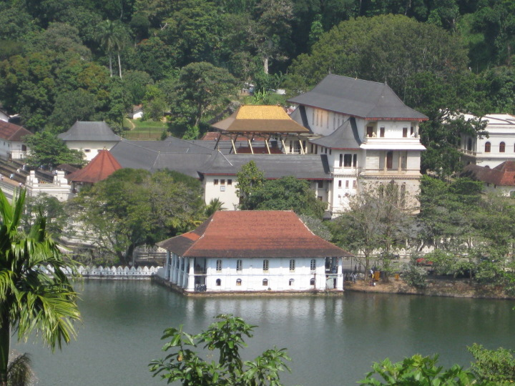
Kandy was the last capital of the Sri Lankan kings and is a World Heritage Site. The name "Kandy" conjures visions of splendor and magnificence. Many of the legends, traditions and folklore are still lovingly kept alive. Drive around the Kandy Lake built by the last Sinhala king, Sri Wickrama Rajasinghe in 1798. Visit the Kandy town and bazaar, the arts and crafts centre, a gem museum and a lapidary. Also visit the Temple of the Tooth Relic in Kandy. Thereafter witness a cultural show.

Dinner and overnight stay at hotel in Kandy

DAY 04 : KANDY / PERADENIYA / PINNAWALA / COLOMBO

DAY 01 : AIRPORT /KANDY

DAY 01 : AIRPORT /KANDY

After breakfast proceed to visit The Royal Botanical Garden in Peradeniya. The botanical garden was first built as a pleasure garden by a Sinhala king and was expanded by the British. It is 147 acres in extent and provides an amazing variety of trees, plants and flowers. http://www.kandycity.org/botanical.htm

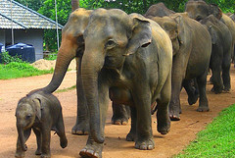
On completion leave for Colombo. En route visit Elephant Orphanage in Pinnawala established in 1975, Commenced with seven orphans. Today some of these orphans enjoy the fortune of seeing their grandchildren born in the same location. The original objective of establishing the orphanage inclined more towards tourism, but is soon became a conservation and educational centre. With the help
of local and foreign elephant experts, Pinnawela
started a scientific captive - breeding programme for elephants. The free movement of the herd enhanced the chances for respective individuals of both sexes to get together and mate. The nearby river played a dominant role in this regard, and in 1984, the first baby of Pinnawela was born. The success story of Pinnawela has drawn the attention of scientists from all over the world. A considerable number of books and research articles on Pinnawela have been published in several languages. The members of the Pinnawela herd have been filmed, videoed and photographed thousands of times by professionals. http://www.elephant.se/zoos/srilanka/pinnawela.htm

Dinner and overnight stay at hotel in Colombo
DAY 05 : COLOMBO / AIRPORT OR BEACH RESORT

DAY 01 : AIRPORT /KANDY

DAY 01 : AIRPORT /KANDY

Breakfast at the hotel. Transfer to Airport or up to Bentota ( from South ) or Marawila ( from North )

-Tour End-

- Tour Category - Standard tour
 | 02 pax | 03 pax | 04 pax | 05-06 pax | 07-12 pax | Single Traveler
Accommodation on HB & Transportation with Russian speaking guide | 408.00 | 357.00 | 328.00 | 311.00 | 300.00 | 730.00
Entrance fees for sights | 81.00 | 81.00 | 81.00 | 81.00 | 81.00 | 81.00
Total package rate (Accommodation + Transportation + Entrance fees) | 489.00 | 438.00 | 409.00 | 392.00 | 381.00 | 811.00

Single Supplement | USD 157.00
Peak period supplement (16/07/14 – 31/07/14) on DBL sharing  Peak period supplement (16/07/14 – 31/07/14) on SGL room | USD 10.00  USD 15.00
Perahera period supplement (01/08/14 – 10/08/14) on DBL sharing  Perahera period supplement (01/08/14 – 10/08/14) on SGL room | USD 25.00  USD 45.00
Peak period supplement (11/08/14 – 31/08/14) on DBL sharing  Peak period supplement (11/08/14 – 31/08/14) on SGL room | USD 10.00  USD 15.00

- Tour Category – Superior tour
 | 02 pax | 03 pax | 04 pax | 05-06 pax | 07-12 pax | Single Traveler
Accommodation on HB & Transportation with Russian speaking guide | 442.00 | 380.00 | 347.00 | 340.00 | 313.00 | 803.00
Entrance fees for sights | 81.00 | 81.00 | 81.00 | 81.00 | 81.00 | 81.00
Total package rate (Accommodation + Transportation + Entrance fees) | 523.00 | 461.00 | 428.00 | 421.00 | 394.00 | 884.00

Single Supplement | USD 165.00
Perahera period supplement (01/08/14 – 10/08/14) on DBL sharing  Perahera period supplement (01/08/14 – 10/08/14) on SGL room | USD 20.00  USD 20.00

- Tour Category – Deluxe Tour
 | 02 pax | 03 pax | 04 pax | 05-06 pax | 07-12 pax | Single Traveler
Accommodation on HB & Transportation with Russian speaking guide | 530.00 | 451.00 | 408.00 | 383.00 | 369.00 | 954.00
Entrance fees for sights | 81.00 | 81.00 | 81.00 | 81.00 | 81.00 | 81.00
Total package rate (Accommodation + Transportation + Entrance fees) | 611.00 | 532.00 | 489.00 | 464.00 | 450.00 | 1035.00

Single Supplement | USD 173.00
Perahera period supplement (01/08/14 – 10/08/14) on DBL sharing  Perahera period supplement (01/08/14 – 10/08/14) on SGL room | USD 40.00  USD 90.00
Peak period supplement (11/08/14 – 31/08/14) on DBL sharing  Peak period supplement (11/08/14 – 31/08/14) on SGL room | USD 20.00  USD 40.00

- Tour Category – Premium tour
 | 02 pax | 03 pax | 04 pax | 05-06 pax | 07-12 pax | Single Traveller
Accommodation on HB & Transportation with Russian speaking guide | 555.00 | 485.00 | 454.00 | 433.00 | 421.00 | 984.00
Entrance fees for sights | 81.00 | 81.00 | 81.00 | 81.00 | 81.00 | 81.00
Total package rate (Accommodation + Transportation + Entrance fees) | 636.00 | 566.00 | 535.00 | 514.00 | 502.00 | 1,065.00

Single Supplement | USD 222.00
Peak period supplement (16/07/14 – 20/07/14) on DBL sharing  Peak period supplement (16/07/14 – 20/07/14) on SGL room | USD 20.00  USD 30.00
Peak period supplement (21/07/14 – 31/07/14) on DBL sharing  Peak period supplement (21/07/14 – 31/07/14) on SGL room | USD 45.00  USD 70.00
Perahera period supplement (01/08/14 – 10/08/14) on DBL sharing  Perahera period supplement (01/08/14 – 10/08/14) on SGL room | USD 75.00  USD 130.00
Peak period supplement (11/08/14 – 31/08/14) on DBL sharing  Peak period supplement (11/08/14 – 31/08/14) on SGL room | USD 45.00  USD 70.00

Supplement for Beach stay transfer beyond Bentota
Bentota - Induruwa - USD 6.00 per person
Bentota - Ahungalla - USD 11.00 per person
Bentota - Hikkaduwa - USD 16.00 per person
Bentota - Galle - USD 22.00 per person
Bentota - Koggala - USD 24.00 per person
Bentota – Dickwella - USD 38.00 per person

Tricnomalee drop - USD 40.00 per person

The above prices include:
- Accommodation in standard rooms on half board basis for 4 nights from dinner on day 1 to breakfast on day 5 at hotels specified or of similar standard.
- Transportation by air-conditioned vehicle from pick up at airport to drop off at airport OR to Bentota (South) or to Marawila (North).
- Service of Russian Speaking National Guide.

Please note the Entrance fees for sights are shown separately. As per the clients’ choice, we can include it or exclude it from the package

Above prices does not include:
- Video Camera permits at Pinnawala Elephant Orphanage.
- Video Camera and Still Camera permits at the Temple of the Tooth Relic in Kandy.
- Lunch throughout the tour.
- Entrance fees to sites not specified above and optional excursions
- Cost of beverage & expenses of a personal nature throughout the tour.
- Tips and Porterage
- Any other services not specified above.

Programme : Explore the Paradise Island
Duration : 5 Days / 4 Nights.
Period/Dates : Summer 2014 (01st May ‘14 to 31st October ‘14)
______________________________________________________________

Tour Itinerary

DAY 01 : AIRPORT / GIRITALE OR DAMBULLA OR HABARANA OR KANDALAMA

DAY 01 : AIRPORT /KANDY

DAY 01 : AIRPORT /KANDY

Arrival at Colombo International Airport where you will be met & welcome by our representative or Tour Guide and transfer to Dambulla. Check in at hotel.

Dinner & overnight stay at hotel as per selected category

DAY 02 : SIGIRIYA / MINNERIYA OR KAUDULLA OR ECO NATIONAL PARK

DAY 01 : AIRPORT /KANDY

DAY 01 : AIRPORT /KANDY

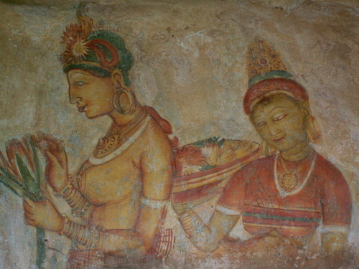
After breakfast proceed to Sigiriya and climb the 5th century Sigiriya rock fortress which is a world heritage site, http://www.worldheritagesite.org/sites/site202.html
Built by King Kashyapa (477-495 AD). The 'Lion Rock' is a citadel of unusual beauty rising 200 meters from the scrub jungle. The rock was the innermost stronghold of
the 70 hectare fortified town. A moat, rampart, and extensive gardens including the renowned water gardens ring the base of the rock. Visit the world-
Renowned frescoes of the 'Heavenly Maidens' of
Sigiriya, which are in a sheltered pocket of the rock approached by a spiral stairway. These frescoes are painted in earth pigments on plaster.

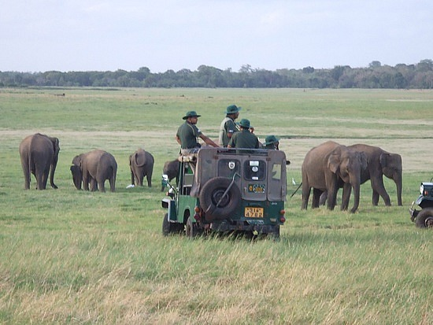
Afternoon proceed an exciting jeep safari at the Minneriya / Kaudulla / Eco National Park by jeep. The extent of the National Park is about 8,889 hectares. There are wet-lands in this National Park, which have international importance, animal and plant species, which are plenty in dry zone, are found in this park. Wild elephants, various amphibians, local and immigrant bird species are plenty in this park. About 160 species of birds, 09 amphibians, 25 reptile species, 26 fish species and more than 78
butterfly species have been found in this area. There are bamboo trees, which are rare in other parks, and wild elephants can be seen conveniently. The significant feature is that these elephants can be seen going closer to them. Transfer from Minneriya to Kandalama.

Dinner & overnight stay at hotel as per selected category

DAY 03 : GIRITALE - KANDALAMA AREA / DAMBULLA / MATALE / KANDY

DAY 01 : AIRPORT /KANDY

DAY 01 : AIRPORT /KANDY

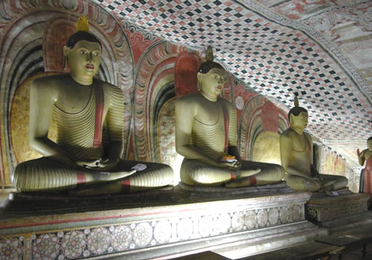
After breakfast leave for Kandy. En route visit Dambulla
Rock Cave temple which was built by king Walagambahu
in the 1st century B.C. and it is a World Heritage Site.
It is the most impressive of Sri Lanka's cave temples.The
Complex of five caves with over 2000 sq. meters of
Painted walls and ceilings is the largest area of paintings
found in the world. It contains over 150 images of the
Buddha of which the largest is the colossal figure of
Buddha carved out of rock and spanning 14 meters.

Visit a spice garden in Matale to see different spices for which Sri Lanka is famous for. Here, clients could see different spices and how some of these spices are grown and processed. Witness a Cookery demonstration.
Kandy was the last capital of the Sri Lankan kings and is a World Heritage Site. The name "Kandy" conjures visions of splendor and magnificence. Many of the legends, traditions and folklore are still lovingly kept alive. Drive around the Kandy Lake built by the last Sinhala king, Sri Wickrama Rajasinghe in 1798. Visit the Kandy town and bazaar, the arts and crafts centre, a gem museum and a lapidary. Also visit the Temple of the Tooth Relic in Kandy. Thereafter witness a cultural show.
Dinner and overnight stay at hotel in Kandy

DAY 04 : KANDY / PERADENIYA / PINNAWALA / NUWARA ELIYA

DAY 01 : AIRPORT /KANDY

DAY 01 : AIRPORT /KANDY

After breakfast visit The Royal Botanical Garden which was first built as a pleasure garden by a Sinhala king and was expanded by the British. http://www.kandycity.org/botanical.htm. It is 147 acres in extent and provides an amazing variety of trees, plants and flowers.
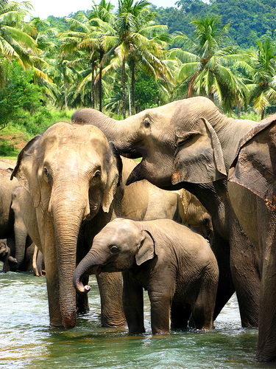
Thereafter proceed to visit The Elephant Orphanage in Pinnawala , established in 1975, Commenced with seven orphans. Today some of these orphans enjoy the fortune of seeing their grandchildren born in the same location. The original objective of establishing the orphanage inclined more towards tourism, but is soon became a conservation and educational centre. With the help of local and foreign elephant experts, Pinnawela started a scientific captive – breeding programme for elephants. The free
movement of the herd enhanced the chances for respective individuals of both sexes to get together and mate. The nearby river played a dominant role in this regard, and in 1984, the first baby of Pinnawela was born. The success story of Pinnawela has drawn the
attention of scientists from all over the world. A considerable number of books and research articles on Pinnawela have been published in several languages. The members of the Pinnawela herd have been filmed, videoed and photographed thousands of times by professionals.

On completion leave for Nuwara Eliya and check in at hotel.

Dinner and overnight stay at hotel in Nuwara Eliya

DAY 05 : NUWARA ELIYA / KITULGALA / SELECTED BEACH RESORT

DAY 01 : AIRPORT /KANDY

DAY 01 : AIRPORT /KANDY

After breakfast visit Nuwara Eliya. Nuwara Eliya, because of its invigorating mountain climate and scenery, is Sri Lankas most popular hill resort. Nuwara Eliya is also the heart of Sri Lankas tea country producing a significant share of the world s best tea. Sri Lanka s highest mountain Pidurutalagala (8282 feet) is located here. Nuwara Eliya also has one of the finest 18 hole golf courses in South Asia. On completion
transfer to Beach resort via Kitulgala. The Kelani River (the broadest river in Sri Lanka ) flowing through
Kitulgala was the main location where the Oscar winning movie “Bridge on the River Kwai” was filmed. On the hill above this town, a prehistoric cave was recently discovered containing large middens of shells from some unknown civilization.

Adventure - Optional excursion in Kitulgala
River rafting for 45 minutes

Price : - 2pax - US$ 45.00 (per person)
Above 2pax - US$ 35.00 (per person)

* Discount of US$ 5.00, if pre-booked by clients at the time of the first booking.

-Tour End-

- Tour Category - Standard tour
 | 02 pax | 03 pax | 04 pax | 05-06 pax | 07-12 pax | Single Traveller
Accommodation on HB & Transportation with Russian speaking guide | 423.00 | 355.00 | 315.00 | 292.00 | 287.00 | 778.00
Entrance fees for sights | 123.00 | 118.00 | 116.00 | 113.00 | 113.00 | 138.00
Total package rate (Accommodation + Transportation + Entrance fees) | 546.00 | 473.00 | 431.00 | 405.00 | 400.00 | 916.00

Single Supplement | USD 131.00
Peak period supplement (16/07/14 – 31/07/14) on DBL sharing  Peak period supplement (16/07/14 – 31/07/14) on SGL room | USD 10.00  USD 15.00
Perahera period supplement (01/08/14 – 10/08/14) on DBL sharing  Perahera period supplement (01/08/14 – 10/08/14) on SGL room | USD 35.00  USD 45.00
Peak period supplement (11/08/14 – 31/08/14) on DBL sharing  Peak period supplement (11/08/14 – 31/08/14) on SGL room | USD 10.00  USD 15.00

- Tour Category – Superior tour
 | 02 pax | 03 pax | 04 pax | 05-06 pax | 07-12 pax | Single Traveller
Accommodation on HB & Transportation with Russian speaking guide | 492.00 | 414.00 | 370.00 | 363.00 | 335.00 | 901.00
Entrance fees for sights | 123.00 | 118.00 | 116.00 | 113.00 | 113.00 | 133.00
Total package rate (Accommodation + Transportation + Entrance fees) | 615.00 | 532.00 | 486.00 | 476.00 | 448.00 | 1,034.00

Single Supplement | USD 158.00
Perahera period supplement (01/08/14 – 10/08/14) on DBL sharing  Perahera period supplement (01/08/14 – 10/08/14) on SGL room | USD 20.00  USD 40.00

- Tour Category – Deluxe tour
 | 02 pax | 03 pax | 04 pax | 05-06 pax | 07-12 pax | Single Traveller
Accommodation on HB & Transportation with Russian speaking guide | 563.00 | 518.00 | 420.00 | 390.00 | 377.00 | 1059.00
Entrance fees for sights | 123.00 | 118.00 | 116.00 | 113.00 | 113.00 | 138.00
Total package rate (Accommodation + Transportation + Entrance fees) | 686.00 | 636.00 | 536.00 | 503.00 | 490.00 | 1,197

Single Supplement | USD 203.00
Perahera period supplement (01/08/14 – 10/08/14) on DBL sharing  Perahera period supplement (01/08/14 – 10/08/14) on SGL room | USD 40.00  USD 90.00
Peak period supplement (11/08/14 – 31/08/14) on DBL sharing  Peak period supplement (11/08/14 – 31/08/14) on SGL room | USD 20.00  USD 40.00

- Tour Category – Premium tour
 | 02 pax | 03 pax | 04 pax | 05-06 pax | 07-12 pax | Single Traveller
Accommodation on HB & Transportation with Russian speaking guide | 641.00 | 547.00 | 505.00 | 464.00 | 451.00 | 1144.00
Entrance fees for sights | 123.00 | 118.00 | 116.00 | 113.00 | 113.00 | 138.00
Total package rate (Accommodation + Transportation + Entrance fees) | 764.00 | 665.00 | 621.00 | 577.00 | 564.00 | 1,282.00

Single Supplement | USD 205.00
Peak period supplement (16/07/14 – 20/07/14) on DBL sharing  Peak period supplement (16/07/14 – 20/07/14) on SGL room | USD 35.00  USD 60.00
Peak period supplement (21/07/14 – 31/07/14) on DBL sharing  Peak period supplement (21/07/14 – 31/07/14) on SGL room | USD 60.00  USD 100.00
Perahera period supplement (01/08/14 – 10/08/14) on DBL sharing  Perahera period supplement (01/08/14 – 10/08/14) on SGL room | USD 90.00  USD 160.00
Peak period supplement (11/08/14 – 31/08/14) on DBL sharing  Peak period supplement (11/08/14 – 31/08/14) on SGL room | USD 60.00  USD 100.00

Supplement for Beach stay transfer beyond Bentota
Bentota - Induruwa - USD 6.00 per person
Bentota - Ahungalla - USD 11.00 per person
Bentota - Hikkaduwa - USD 16.00 per person
Bentota - Galle - USD 22.00 per person
Bentota - Koggala - USD 24.00 per person
Bentota – Dickwella - USD 38.00 per person

Tricnomalee drop - USD 40.00 per person

The above prices include:
- Accommodation in standard rooms on half board basis for 4 nights from dinner on day 1 to breakfast on day 5 at hotels specified or of similar standard.
- Transportation by air-conditioned vehicle from pick up at airport to drop off at beach Hotel up to Beruwala (South).
- Services of Russian Speaking National Guide.

Please note the Entrance fees for sights are shown separately. As per the clients’ choice, we can include it or exclude it from the package

Above prices does not include:
- Video Camera permits at Pinnawala Elephant Orphanage.
- Video Camera and Still Camera permits at the Temple of the Tooth Relic in Kandy.
- Lunch throughout the tour.
- Entrance fees to sites not specified above and optional Excursions
- Cost of beverage & expenses of a personal nature throughout the tour.
- Tips and Porterage

Programme : Culture & Nature
Duration : 7 Days / 6 Nights.
Period/Dates : Summer 2014 (01st May ‘14 to 31st October ‘14)
_________________________________________________________________________________________

Tour Itinerary
DAY 01 : AIRPORT / COLOMBO

DAY 01 : AIRPORT /KANDY

DAY 01 : AIRPORT /KANDY

Arrival at Colombo International Airport where you will be met & welcome by our representative or Tour Guide and transfer to Colombo. Check in at hotel.
Afternoon proceed on at city tour of Colombo. In the afternoon, do a city tour of Colombo. Colombo like many capital cities in developing countries is fast
changing its face. Almost overnight, skyscrapers arise from where old buildings once stood.Yet in some parts, the old world charm is retained. For example, there is a 100-year-old clock tower and several British built colonial buildings. Other places of interest are the Pettah bazaar – where one can shop for bargain, a Hindu and a Buddhist temple, residential areas where you find the
stately homes of the affluent, the Bandaranaike Memorial International Conference Hall an outright gift to Sri Lanka from the People’s Republic of China.

Dinner and overnight stay at hotel in Colombo.

DAY 02 : COLOMBO / ANURADHAPURA / GIRITALE - KANDALAMA AREA

DAY 01 : AIRPORT /KANDY

DAY 01 : AIRPORT /KANDY

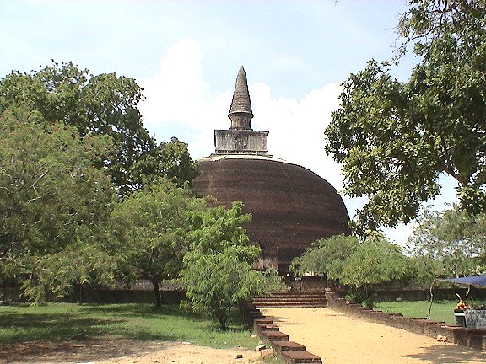
After breakfast proceed to visit Anuradhapura. It was The first capital and undoubtedly the grandest city of The ancient Ceylon. It is the home of two World Heritage Sites. Many places of historical and archaeological interest Could be visited. Sri Maha Bodhi ( Sacred Bo-Tree ) was
brought as a sapling of the tree under which Prince Siddhartha attained to enlightenment and it
is over 2200 years old and is the oldest historically documented tree in the world. The Brazen Palace
(2nd century B.C), the 1600 stone columns you see are all that is left of a magnificent multi-storied residence for monks. Ruwanweliseya (2nd century B.C) is the most famous of all the Dagobas. It originally depicted the perfect 'bubble shape" that modern restoration has not been able to accurately reproduce. 'Samadhi' Buddha statue (4th century AD) is one of the most famous statues, depicting the Buddha in a state of 'Samadhi' or deep meditation. Isurumuniya rock temple (3rd century B.C) is well known for its rock carvings. www.worldheritagesite.org/sites/site200.html.

On completion proceed to the area of your choice and check in at hotel.

Dinner and overnight stay at Hotel as per selected category

DAY 03 : SIGIRIYA / POLONNARUWA

DAY 01 : AIRPORT /KANDY

DAY 01 : AIRPORT /KANDY

After breakfast proceed to Sigiriya and climb the 5th century Sigiriya rock fortress which is a world heritage site, http://www.worldheritagesite.org/sites/site202.html Built by King Kashyapa (477-495 AD). The 'Lion Rock' is a citadel of unusual beauty rising 200 meters from the
scrub jungle. The rock was the innermost stronghold of the 70 hectare fortified town. A moat, rampart, and extensive gardens including the renowned water gardens ring the base of the rock. Visit the world-renowned frescoes of the 'Heavenly Maidens' of
Sigiriya, which are in a sheltered pocket of the rock approached by a spiral stairway. These frescoes are painted in earth pigments on plaster.
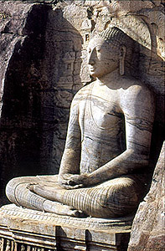
Afternoon visit Polonnaruwa, which was the 2nd capital city of Sri Lanka
built in the 11th and 12th centuries AD, and which is a world heritage
site. Here you can see the ruins of the Royal Palace, the Gal Viharaya
where 4 splendid statues of the Buddha in 'Upright', 'Sedentary' and
'Recumbent' postures carved out of rock could be seen, the Audience
Hall, the Lotus Bath, the statue of king Parakramabahu, and e Parakrama
Samudraya - a lake built by King Parakramabahu the great. There
are also monuments of famous places of worship such as the Shiva
Temple, the Lankathilake, the Watadage, the Galpotha, the Kiri Vehera
and the remains of a former Temple of the Tooth Relic.
http://www.worldheritagesite.org/sites/site201.html

Dinner and overnight stay at Hotel as per selected category

DAY 04 : GIRITALE – KANDALAMA ARE / DAMBULLA / MATALE / KANDY

DAY 01 : AIRPORT /KANDY

DAY 01 : AIRPORT /KANDY

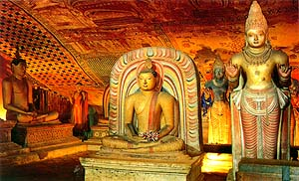
After breakfast leave for Kandy. En route visit Dambulla Rock Cave temple which was built by king Walagambahu in the 1st century B.C. and it is a World Heritage Site. It is the most impressive of Sri Lanka's cave temples. The
complex of five caves with over 2000 sq. meters of painted walls and ceilings is the largest area of paintings found in the world. It contains over 150 images of the Buddha of which the largest is the colossal figure of the Buddha carved out of rock and spanning 14 meters. www.worldheritagesite.org/sites/site561.html

Visit a spice garden in Matale to see different spices for which Sri Lanka is famous for. Here, clients could see different spices and how some of these spices are grown and processed. Witness a Cookery demonstration. On completion proceed to Kandy.

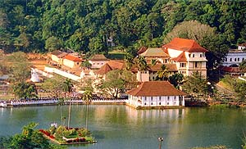
Kandy was the last capital of the Sri Lankan kings and is a World Heritage Site. The name "Kandy" conjures visions of splendour and magnificence. Many of the legends, traditions and folklore are still lovingly kept
alive. Drive around the Kandy Lake built by the last Sinhala king, Sri Wickrama Rajasinghe in 1798. Visit the Kandy town and bazaar, the arts and crafts centre, a gem museum and a lapidary. Also visit the Temple of the Tooth Relic I n Kandy. Thereafterwitness a cultural show.

Dinner and overnight stay at hotel in Kandy

DAY 05 : KANDY / PERADENIYA / PINNAWALA / NUWARA ELIYA

DAY 01 : AIRPORT /KANDY

DAY 01 : AIRPORT /KANDY

After breakfast visit The Royal Botanical Garden in Peradeniya which was first built as a pleasure garden by a Sinhala king and was expanded by the British It is 147 acres in extent and provides an amazing variety of trees, plants and flowers. http://www.kandycity.org/botanical.htm.

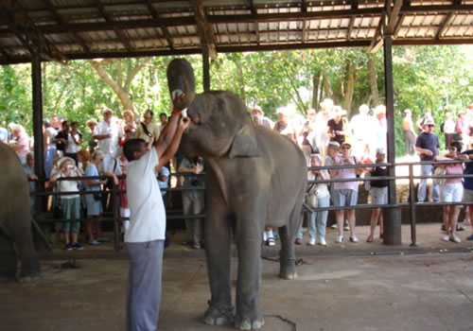
Transfer from Peradeniya to Pinnawala. The Pinnawela Elephant Orphanage, established in 1975, commenced with Seven orphans. Today some of these orphans enjoy the Fortune of seeing their grandchildren born in the same location. Original objective of establishing the orphanage inclined more
towards tourism, but is soon became a conservation and educational centre. With the help of local and foreign elephant experts, Pinnawela started a scientific
captive - breeding programme for elephants. The free
movement of the herd enhanced the chances for respective individuals of both sexes to get together and mate. The nearby river played a dominant role in this regard, and in 1984, the first baby of Pinnawela was born. The success story of Pinnawela has drawn the attention of scientists from all over the world. A considerable number of books and research articles on Pinnawela have been published in several languages. The members of the Pinnawela herd have been filmed, videoed and photographed thousands of times by professionals. www.elephant.se/zoos/srilanka/pinnawela.htm

On completion leave for Nuwara Eliya. Check in at hotel.

Dinner and overnight stay at hotel in Nuwara Eliya.

DAY 06 : NUWARA ELIYA / YALA

DAY 01 : AIRPORT /KANDY

DAY 01 : AIRPORT /KANDY

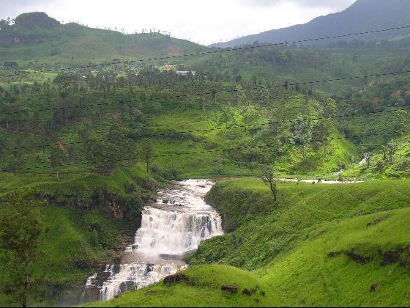
After breakfast visit Nuwara Eliya. Nuwara Eliya, because of its invigorating mountain climate and scenery, is Sri Lankas most popular hill resort. Nuwara Eliya is also the heart of Sri Lankas tea country producing a significant share of the world s best tea. Sri Lanka s highest mountain Pidurutalagala (8282 feet) is located here. Nuwara Eliya also has one of the finest 18 hole golf courses in South Asia. On completion leave for Yala. Check in at hotel and rest of the day at leisure.

Dinner and overnight stay at hotel as per selected category

DAY 07 : YALA / GALLE / SELECTED BEACH RESORT.

DAY 01 : AIRPORT /KANDY

DAY 01 : AIRPORT /KANDY

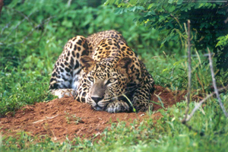
Morning proceed on an exciting jeep safari at Yala National Park Elephant, Leopard, sloth bear, Spotted Dear, Wild Boar and sambhur. Apartfrom them small mammals such as Black naped hare, Grey, Ruddy & Striped necked
mongoose, Grey Languor & porcupine are common small mammals. Park is also famous for its abundant bird life. Over 140 species have recorded so far within the park. Changeable Hawk Eagle, Crested serpent Eagle, Malabar pied Hornbill, Jungle fowl, painted Stork, white Ibis and Black necked Stork are commonly seen.

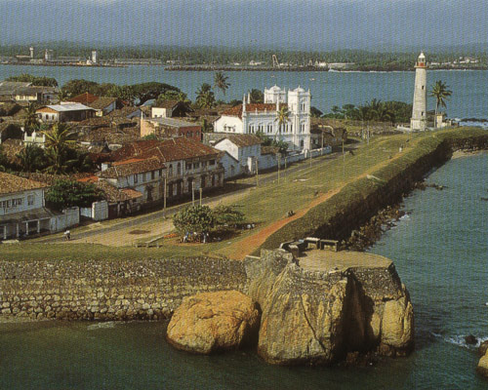
Thereafter transfer to your beach resort. En route visit Galle which was once the chief port of Ceylon. It is still well known for hand-made lace. You can also visit the Galle Fort (spanning 90 acres) which was originally built by the Portuguese and later extended by the Dutch in 1663. This is a World Heritage Site

Transfer from Galle to Beach Hotel or up to Colombo.

-Tour End-

- Tour Category - Standard tour
 | 02 pax | 03 pax | 04 pax | 05-06 pax | 07-12 pax | Single Traveler
Accommodation on HB & Transportation with Russian speaking guide | 626.00 | 517.00 | 456.00 | 416.00 | 409.00 | 1,168.00
Entrance fees for sights | 185.00 | 175.00 | 170.00 | 170.00 | 170.00 | 205.00
Total package rate (Accommodation + Transportation + Entrance fees) | 811.00 | 692.00 | 626.00 | 586.00 | 579.00 | 1,373.00

Single Supplement | USD 185.00
Peak period supplement (16/07/14 – 31/07/14) on DBL sharing  Peak period supplement (16/07/14 – 31/07/14) on SGL room | USD 10.00  USD 15.00
Perahera period supplement (01/08/14 –10/08/14) on DBL sharing  Perahera period supplement (01/08/14 –10/08/14) on SGL room | USD 25.00  USD 45.00
Peak period supplement (11/08/14 – 31/08/14) on DBL sharing  Peak period supplement (11/08/14 – 31/08/14) on SGL room | USD 10.00  USD 15.00

- Tour Category – Superior tour
 | 02 pax | 03 pax | 04 pax | 05-06 pax | 07-12 pax | Single Traveler
Accommodation on HB & Transportation with Russian speaking guide | 677.00 | 574.00 | 516.00 | 481.00 | 473.00 | 1,230.00
Entrance fees for sights | 185.00 | 175.00 | 170.00 | 170.00 | 170.00 | 205.00
Total package rate (Accommodation + Transportation + Entrance fees) | 862.00 | 749.00 | 686.00 | 651.00 | 643.00 | 1435.00

Single Supplement | USD 220.00
Perahera period supplement (01/08/14 –10/08/14) on DBL sharing  Perahera period supplement (01/08/14 –10/08/14) on SGL room | USD 20.00  USD 20.00

- Tour Category – Deluxe Tour
 | 02 pax | 03 pax | 04 pax | 05-06 pax | 07-12 pax | Single Traveler
Accommodation on HB & Transportation with Russian speaking guide | 812.00 | 683.00 | 588.00 | 568.00 | 552.00 | 1509.00
Entrance fees for sights | 185.00 | 175.00 | 170.00 | 170.00 | 170.00 | 205.00
Total package rate (Accommodation + Transportation + Entrance fees) | 997.00 | 858.00 | 758.00 | 738.00 | 722.00 | 1714.00

Single Supplement | USD 270.00
Peak period supplement (20/07/14 – 31/07/14) on DBL sharing  Peak period supplement (20/07/14 – 31/07/14) on SGL room | USD 10.00  USD 10.00
Peak period supplement (01/08/14 – 10/08/14) on DBL sharing  Peak period supplement (01/08/14 – 10/08/14) on SGL room | USD 30.00  USD 50.00

- Tour Category – Premium tour
 | 02 pax | 03 pax | 04 pax | 05-06 pax | 07-12 pax | Single Traveller
Accommodation on HB & Transportation with Russian speaking guide | 950.00 | 818.00 | 745.00 | 701.00 | 658.00 | 1718.00
Entrance fees for sights | 185.00 | 175.00 | 170.00 | 170.00 | 170.00 | 205.00
Total package rate (Accommodation + Transportation + Entrance fees) | 1,135.00 | 993.00 | 915.00 | 871.00 | 828.00 | 1,923.00

Single Supplement | USD 340.00
Peak period supplement (16/07/14 – 20/07/14) on DBL sharing  Peak period supplement (16/07/14 – 20/07/14) on SGL room | USD 35.00  USD 60.00
Peak period supplement (21/07/14 – 31/07/14) on DBL sharing  Peak period supplement (21/07/14 – 31/07/14) on SGL room | USD 70.00  USD 110.00
Perahera period supplement (01/08/14 – 10/08/14) on DBL sharing  Perahera period supplement (01/08/14 – 10/08/14) on SGL room | USD 100.00  USD 170.00
Peak period supplement (11/08/14 – 31/08/14) on DBL sharing  Peak period supplement (11/08/14 – 31/08/14) on SGL room | USD 70.00  USD 110.00

Supplement for Beach stay transfer beyond Colombo

Colombo – Negombo - USD 28.00 per person
Colombo – Marawila - USD 34.00 per person

Tricnomalee drop - USD 45.00 per person

The above prices include:
- Accommodation in standard rooms on half board basis for 6 nights from dinner on day 1 to breakfast on day 7 at hotels specified or of similar standard.
- Transportation by air-conditioned vehicle from pick up at airport to drop off in Colombo.(Departure transfer is not included)
- Services of a Russian Speaking National Guide.

Please note the Entrance fees for sights are shown separately. As per the clients’ choice, we can include it or exclude it from the package

Above prices does not include:
- Video Camera permits at Pinnawala Elephant Orphanage.
- Video Camera and Still Camera permits at the Temple of the Tooth Relic in Kandy.
- Lunch throughout the tour.
- Entrance fees to sites not specified above.
- Cost of beverage & expenses of a personal nature throughout the tour.

Hotels utilized in the tours
Town / City | Tour Category | Hotels
Colombo | Standard | Palm Village, Wattala - www.palmvillagehotel.com
Colombo | Superior | Grand Oriental Hotel, Colombo - www.grandorientalhotel.com
Colombo | Deluxe | Pegasus Reef Hotel , Wattala - www.pegasusreefhotel.com
Colombo | Premium | Cinnamon Lakeside, Colombo - www.cinnamonhotels.com
Kandy | Standard | Hotel Hill Top, Kandy - www.aitkenspencehotels.com  The Swiss Residence – www.theswissresidence.com  Devon Hotel, Kandy - www.devonsrilanka.com
Kandy | Superior | Earls Regent, Kandy www.ealrrsegent.com
Kandy | Deluxe | Amaya Hills Kandy - www.amayaresorts.com
Kandy | Premium | Earls Regency, Kandy - www.aitkenspencehotels.com
Sigirya / Habarana / Dambulla / Giritale /  Kandalama | Standard | Kassapa Lions Rock, Sigiriya - www.kassapalionsrock.com  Camillia Resort, Dambulla – www.camelliaresortspa.com
Sigirya / Habarana / Dambulla / Giritale /  Kandalama | Superior | Sigiriya Village, Sigiriya - www.sigiriyavillage.com
Sigirya / Habarana / Dambulla / Giritale /  Kandalama | Deluxe | Amaya Lake, Dambulla - www.amayaresorts.com
Sigirya / Habarana / Dambulla / Giritale /  Kandalama | Premium | Cinammon Lodge, Habarana -www.johnkeellshotels.com
Nuwara Eliya | Standard | Galway Forest Lodge, Nuwara Eliya – www.galway.lk
Nuwara Eliya | Superior | Avian Breeze, Nuwara Eliya www.avianholidays.lk
Nuwara Eliya | Deluxe | Avian Breeze, Nuwara Eliya www.avianholidays.lk
 | Premium | The Tea Factory, Kandapola – www.aitkenspencehotels.com
Tissamahara / Kataragama / Yala | Standard | Villa Safari, Weerawila – www.villasafari.lk
Tissamahara / Kataragama / Yala | Superior | Chandrika Hotel, Tissamaharama - www.chandrikahotel.com
Tissamahara / Kataragama / Yala | Deluxe | Mandara Rosen, Kataragama – www.rosenhotelsrilanka.com
Tissamahara / Kataragama / Yala | Premium | Cinnamon Wild, Kataragama – www.cinnamonhotels.com

NB: Standard rooms are used in all the hotels, unless specially mentioned

General Terms & Conditions
NB : The price includes governmental taxes of 1% cess, 12% VAT and 2% Nation Building Tax (applicable only to hotel rates and not DMC services).

Should there be a revision on the above taxes or introduction of NBT to DMC services or any other additional taxes levied by the government, this will be passed on to you and shall be liable for due settlement of same within the legal time frame.

Child Policy
Children below 2 years sharing parents room - Free of Charge

Children from 2-12 years sharing parents room - 30% Discount on the adult rate based on 02 pax

3rd person sharing a triple room - 10% on the per person sharing double room rate

** Please note that the extra bed in a triple room will be a foldable and rollaway bed.

Other Condition
- Optional excursions and additional services could be provided for which we will charge additionally.
- Visits to wild life parks will be at client's own risk
- Jeeps available are very basic with basic insurance cover (not comprehensive as in the case of vehicles used for tours).

Cancellation Charges:
a.) 7 days or less - 100% cancellation charge
b.) Between 8 days and 14 days - 50% cancellation charges or the equivalent of the first two days
charges depending on the programme and period of stay.
c.) Above 15 days - No cancellation charges provided no commitment or advances are
Made to 3rd parties

Hotel rules and regulations:
The official check-in time at all hotels will be 1200hrs.
The official check-out time at all hotels will be 1100hrs.
Cancellation policy will be applicable for any reduction of rooms after the release period.

Visas:

All countries should apply for visa online through www.eta.gov.lk

Airport Tax:
Cost of Airport tax is included to the flight ticket. However, this could differ for Charter flights.

