Round Tours

Valid from 01st November 2019 – 30th April 2020

Content
Tour Name Page Number
- Sri Lanka Map 01 – 01
- Cultural Highlights (03 Days / 02 Nights Tour) 02 – 04
- Hill Country (03 Days / 02 Nights Tour) 05 - 07
- Exotic Lanka (04 Days / 03 Nights Tour) 08 – 11
- Exotic Lanka Special (04 Days / 03 Nights Tour) 12 – 15
- Best of Sri Lanka (04 Days / 03 Nights Tour) 15 – 17
- Cultural Experience (05 Days / 04 Nights Tour) 18 – 21
- Explore the Paradise Island (05 Days / 04 Nights Tour) 22 – 25
- Wonders of Ceylon (06 Days / 05 Nights Tour) 26 – 29
- Culture and Nature (07 Days / 06 Nights Tour) 30 – 33
- Hotels utilized in tours 34 – 34
- Seasonal supplements in each hotel 35 – 35
- General Terms and Conditions 36 – 36

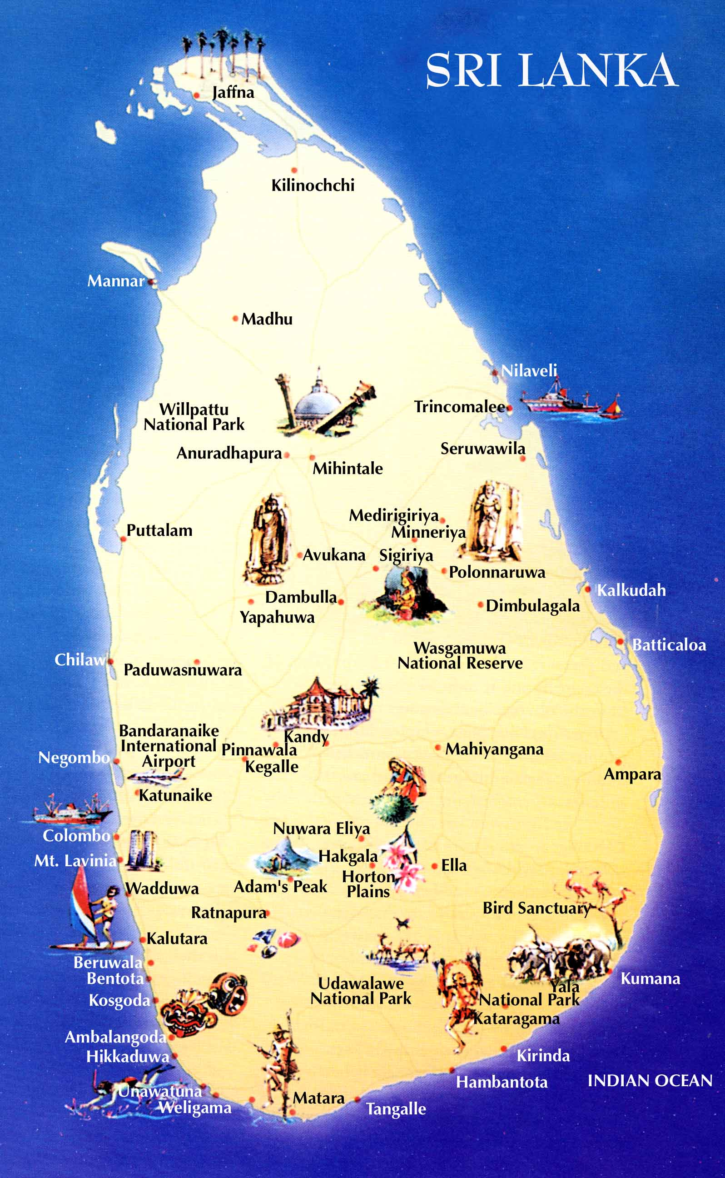

Programme : Cultural Highlights
Duration : 3 Days / 2 Nights
Period/Dates : Winter 2019/20 (01st November 2019 to 30th April 2020)
________________________________________________________________________________________________________________________________
Tour Itinerary
DAY 01 : AIRPORT / KANDY

Arrival at Colombo International Airport where you will be met & welcome by Aitken Spence Tour Guide and transfer to Kandy.
Evening visit the Temple of the Tooth Relic in Kandy, then proceed to an auditorium to witness a cultural show.
Dinner and overnight stay at the hotel in Kandy.
DAY 02 : KANDY / SIGIRIYA / DAMBULLA / MATALE / KANDY

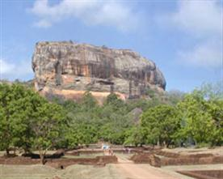
After breakfast proceed to Sigiriya and climb the 5th century Sigiriya rock fortress which is a world heritage site, built by King Kashyapa (477 - 495 AD). The ‘Lion Rock' is a citadel of unusual beauty rising 200 meters from the scrub jungle. The rock was innermost stronghold of the 70 hectare fortified town. A moat, rampart, and extensive gardens including the renowned water gardens ring the base of the rock. Visit the World -renowned frescoes of 'Heavenly Maidens' of Sigiriya, Which are in a sheltered pocket of the rock approached by a spiral stairway. These frescoes are painted in earth pigments on plaster.
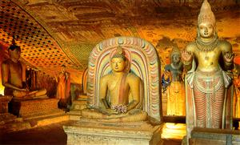
On completion return to Kandy. En route visit Dambulla Rock Cave Temple was built by king Walagambahu in the 1st century B.C. and it is a World Heritage Site. It is the most impressive of Sri Lanka's cave temples. The complex of five caves with over 2000 sq. meters of painted walls and ceilings is the largest area of paintings found in the world. It contains over 150 images of the Buddha of which the largest is the colossal figure of the Buddha carved out of rock and spanning 14 meters.
Thereafter visit a spice garden in Matale to see different spices for which Sri Lanka is famous for. Here, clients could see different spices and how some of these spices are grown and processed.
Dinner and overnight stay at the hotel in Kandy.
DAY 03 : KANDY / PERADENIYA / PINNAWALA / SELECTED BEACH RESORT

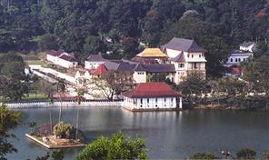
After breakfast proceed on city tour of Kandy. Kandy was the last capital of the Sri Lankan kings and is a World Heritage Site. The name "Kandy" conjures visions of splendor and magnificence. Many of the legends, traditions and folklore are still lovingly kept alive. Drive around the Kandy Lake built by the last Sinhala king, Sri Wickrama Rajasinghe in 1798. Visit the Kandy town and bazaar, the arts and crafts centre, a gem museum and a lapidary.
Thereafter visit The Royal Botanical Garden in Peradeniya. The botanical garden was first built as a Pleasure garden by a Sinhala king and was expanded by the British. It is 147 acres in extent and provides an amazing variety of trees, plants and flowers.
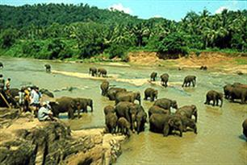
On completion transfer to Beach Hotel. En route visit Elephant Orphanage in Pinnawala, established in 1975, commenced with seven orphans. Today some of these orphans enjoy the fortune of seeing their Grand children born in the same location. The original objective of establishing the orphanage inclined more towards tourism, but is soon became a conservation and educational centre. With the help of local and foreign elephant experts, Pinnawela started a scientific captive-breeding programme for elephants. The free movement of the herd enhanced the chances for respective individuals of both sexes to get together and mate.
Transfer from Pinnawala to Beach Resort up to Beruwala from South and Marawila from North.
-Tour End-
- Tour Category - Standard
 | 02 pax. | 03 pax. | 04 pax. | 05-06 pax. | 07-12 pax. | 1 pax.
Accommodation on HB & Transportation with Russian speaking guide | 240.00 | 205.00 | 175.00 | 155.00 | 145.00 | 450.00
Entrance fees for sights | 91.00 | 91.00 | 91.00 | 91.00 | 91.00 | 91.00
Total package rate  (Accommodation + Transportation + Entrance fees) | 331.00 | 296.00 | 266.00 | 246.00 | 236.00 | 541.00

Single Supplement | USD 52.00
Peak period supplement (20/12/19 – 15/01/20) on DBL sharing  Peak period supplement (20/12/19 – 15/01/20) on SGL room | USD 10.00  USD 20.00

- Tour Category – Superior
 | 02 pax. | 03 pax. | 04 pax. | 05-06 pax. | 07-12 pax. | 1 pax.
Accommodation on HB & Transportation with Russian speaking guide | 260.00 | 220.00 | 185.00 | 170.00 | 150.00 | 490.00
Entrance fees for sights | 91.00 | 91.00 | 91.00 | 91.00 | 91.00 | 91.00
Total package rate  (Accommodation + Transportation + Entrance fees) | 351.00 | 311.00 | 276.00 | 261.00 | 241.00 | 581.00

Single Supplement | USD 56.00
Peak period supplement (20/12/19 – 30/04/20) on DBL sharing  Peak period supplement (20/12/19 – 30/04/20) on SGL room | USD 15.00  USD 20.00

- Tour Category – Deluxe
 | 02 pax. | 03 pax. | 04 pax. | 05-06 pax. | 07-12 pax. | 1 pax.
Accommodation on HB & Transportation with Russian speaking guide | 275.00 | 240.00 | 210.00 | 188.00 | 175.00 | 515.00
Entrance fees for sights | 91.00 | 91.00 | 91.00 | 91.00 | 91.00 | 91.00
Total package rate  (Accommodation + Transportation + Entrance fees) | 366.00 | 331.00 | 301.00 | 279.00 | 266.00 | 606.00

Single Supplement | USD 125.00
Peak period supplement (21/12/19 – 15/01/20) on DBL sharing  Peak period supplement (21/12/19 – 15/01/20) on SGL room | USD 30.00  USD 40.00
Shoulder period supplement (16/01/20 – 31/03/20) on DBL sharing  Shoulder period supplement (16/01/20 – 31/03/20) on SGL room | USD 20.00  USD 20.00

Supplement for Beach stay transfer beyond Bentota
Bentota - Induruwa - USD 6.00 per person
Bentota - Ahungalla - USD 11.00 per person
Bentota - Hikkaduwa - USD 16.00 per person
Bentota - Galle - USD 22.00 per person
Bentota - Koggala - USD 24.00 per person
Bentota - Weligama - USD 30.00 per person
Bentota - Dickwella - USD 38.00 per person
Bentota - Tangalle - USD 44.00 per person
Trincomalee drop - USD 60.00 per person

The above prices include:
• Accommodation in standard rooms on Half Board basis for 2 nights from dinner on day 1 to breakfast on day 3 at hotels specified or of similar standard.
• Transportation by air-conditioned vehicle from pick up at airport to drop off at Beach Hotel - up to Bentota (from South) and Marawila (from North)
• Service of a Russian speaking National guide

Please note the Entrance fees for sights are shown separately. As per the clients’ choice, we can include it or exclude it from the package

Above prices does not include:
• Video Camera permits at Pinnawala Elephant Orphanage.
• Video Camera and Still Camera permits at the Temple of the Tooth Relic in Kandy.
• Lunch throughout the tour.
• Entrance fees to sites not specified above.
• Cost of beverage and expenses of a personal nature throughout the tour
• Tips and Porterage
• Any other services not specified above.
Programme : Hill Country
Duration : 3 Days / 2 Nights
Period/Dates : Winter 2019/20 (01st November 2019 to 30th April 2020)
______________________________________________________________________________________________________
Tour Itinerary
DAY 01 : AIRPORT / KANDY

Arrival at Colombo International Airport where you will be met & welcome by Aitken Spence Tour Guide and transfer to Kandy.
Afternoon proceed on city tour of Kandy. Kandy was the last capital of the Sri Lankan kings and is a World Heritage Site. The name "Kandy" conjures visions of splendor and magnificence. Many of the legends, traditions and folklore are still lovingly kept alive. Drive around the Kandy Lake built by the last Sinhala king, Sri Wickrama Rajasinghe in 1798. Visit the Kandy town and bazaar, the arts and crafts centre, a gem museum and a lapidary.
Thereafter visit The Royal Botanical Garden in Peradeniya. The botanical garden was first built as a Pleasure garden by a Sinhala king and was expanded by the British. It is 147 acres in extent and provides an amazing variety of trees, plants and flowers.
Evening visit the Temple of the Tooth Relic in Kandy. Thereafter proceed to witness a cultural show.
Dinner and overnight stay at the hotel in Kandy.
DAY 02 : KANDY / PINNAWELA / NUWARA ELIYA

After breakfast proceed to Nuwara Eliya.
En route visit Elephant Orphanage in Pinnawala, established in 1975, commenced with seven orphans. Today some of these orphans enjoy the fortune of seeing their Grand children born in the same location. The original objective of establishing the orphanage inclined more towards tourism,but is soon became a conservation and educational centre. With the help of local and foreign elephant experts, Pinnawela started a scientific captive-breeding programme for elephants. The free movement of the herd enhanced the chances for respective individuals of both sexes to get together and mate. The nearby river played a dominant role in this regard, and in 1984, the first baby of Pinnawela was born. The success story of Pinnawela has drawn the attention of scientists from all over the world.
Proceed to Nuwara Eliya.
Dinner and overnight stay at the hotel in Nuwara Eliya.
DAY 03 : NUWARA ELIYA / KITULGALA / SELECTED BEACH RESORT

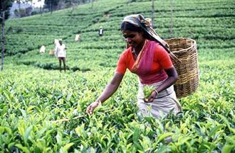
After breakfast visit Nuwara Eliya. Nuwara Eliya, because of its invigorating mountain climate and scenery, is Sri Lankas most popular hill resort. Nuwara Eliya is also the heart of Sri Lankas tea country producing a significant share of the world s best tea. Sri Lanka s highest mountain Pidurutalagala (8282 feet) is located here. Nuwara Eliya also has one of the finest 18 hole golf courses in South Asia. On completion transfer to Beach resort via Kitulgala. The Kelani River (the broadest river in Sri Lanka ) flowing through Kitulgala was the main location where the Oscar winning movie “Bridge on the River Kwai” was filmed. On the hill above this town, a prehistoric cave was recently discovered containing large middens of shells from some unknown civilization.
Adventure - Optional excursion in Kitulgala – River rafting for 45 minutes
Price : - 2pax - US$ 45.00 (per person)
Above 2pax - US$ 35.00 (per person)
* Discount of US$ 5.00, if pre-booked by clients at the time of the first booking.
Transfer from Nuwara Eliya to Beach Resort up to Beruwala from South and Marawila from North.
-Tour End-
- Tour Category – Standard
 | 02 pax. | 03 pax. | 04 pax. | 05-06 pax. | 07-12 pax. | 1 pax.
Accommodation on HB & Transportation with Russian speaking guide | 240.00 | 210.00 | 175.00 | 160.00 | 145.00 | 455.00
Entrance fees for sights | 50.00 | 50.00 | 50.00 | 50.00 | 50.00 | 50.00
Total package rate  (Accommodation + Transportation + Entrance fees) | 290.00 | 260.00 | 225.00 | 210.00 | 195.00 | 505.00

Single Supplement | USD 55.00
Peak period supplement (20/12/19 – 15/01/20) on DBL sharing  Peak period supplement (20/12/19 – 15/01/20) on SGL room | USD 10.00  USD 20.00

- Tour Category – Superior
 | 02 pax. | 03 pax. | 04 pax. | 05-06 pax. | 07-12 pax. | 1 pax.
Accommodation on HB & Transportation with Russian speaking guide | 270.00 | 235.00 | 205.00 | 185.00 | 170.00 | 500.00
Entrance fees for sights | 50.00 | 50.00 | 50.00 | 50.00 | 50.00 | 50.00
Total package rate  (Accommodation + Transportation + Entrance fees) | 320.00 | 285.00 | 255.00 | 235.00 | 220.00 | 550.00

Single Supplement | USD 68.00
Peak period supplement (20/12/19 – 31/03/20) on DBL sharing  Peak period supplement (20/12/19 – 31/03/20) on SGL room | USD 08.00  USD 10.00

- Tour Category – Deluxe
 | 02 pax. | 03 pax. | 04 pax. | 05-06 pax. | 07-12 pax. | 1 pax.
Accommodation on HB & Transportation with Russian speaking guide | 285.00 | 250.00 | 220.00 | 200.00 | 185.00 | 530.00
Entrance fees for sights | 50.00 | 50.00 | 50.00 | 50.00 | 50.00 | 50.00
Total package rate  (Accommodation + Transportation + Entrance fees) | 335.00 | 300.00 | 270.00 | 250.00 | 235.00 | 580.00

Single Supplement | USD 80.00
Shoulder period supplement (01/12/19 – 20/12/19) on DBL sharing  Shoulder period supplement (01/12/19 – 20/12/19) on SGL room | USD 08.00  USD 15.00
Peak period supplement (21/12/19 – 15/01/20) on DBL sharing  Peak period supplement (21/12/19 – 15/01/20) on SGL room | USD 23.00  USD 35.00
Shoulder period supplement (16/01/20 – 31/03/20) on DBL sharing  Shoulder period supplement (16/01/20 – 31/03/20) on SGL room | USD 18.00  USD 25.00
Shoulder period supplement (01/04/20 – 30/04/20) on DBL sharing  Shoulder period supplement (01/04/20 – 30/04/20) on SGL room | USD 08.00  USD 15.00
Supplement for Beach stay transfer beyond Bentota
Bentota - Induruwa - USD 6.00 per person
Bentota - Ahungalla - USD 11.00 per person
Bentota - Hikkaduwa - USD 16.00 per person
Bentota - Galle - USD 22.00 per person
Bentota - Koggala - USD 24.00 per person
Bentota - Weligama - USD 30.00 per person
Bentota - Dickwella - USD 38.00 per person
Bentota - Tangalle - USD 44.00 per person
Trincomalee drop - USD 75.00 per person

The above prices include:
• Accommodation in standard rooms on Half Board basis for 2 nights from dinner on day 1 to breakfast on day 3 at hotels specified or of similar standard.
• Transportation by air-conditioned vehicle from pick up at airport to drop off at Beach Hotel - up to Bentota (from South) and Marawila (from North)
• Service of a Russian speaking National guide

Please note the Entrance fees for sights are shown separately. As per the clients’ choice, we can include it or exclude it from the package

Above prices does not include:
• Video Camera permits at Pinnawala Elephant Orphanage.
• Video Camera and Still Camera permits at the Temple of the Tooth Relic in Kandy.
• Lunch throughout the tour.
• Entrance fees to sites not specified above.
• Cost of beverage and expenses of a personal nature throughout the tour
• Tips and Porterage
• Any other services not specified above.
Programme : Exotic Lanka
Duration : 4 Days / 3 Nights.
Period/Dates : Winter 2019/20 (01st November 2019 to 30th April 2020)
________________________________________________________________________________________________________________________________________
Tour Itinerary
DAY 01 : AIRPORT / DAMBULLA or HABARANA or SIGIRIYA

Arrival at Colombo International Airport where you will be met & welcome by our Tour Guide and transfer to area of choice.
Dinner and overnight stay at hotel as per selected category.
DAY 02 : SIGIRIYA

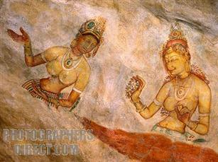
After breakfast proceed to Sigiriya and climb the 5th century Sigiriya rock fortress which is a world heritage site, built by King Kashyapa (477 - 495 AD). The 'Lion Rock' is a citadel of unusual beauty rising 200 meters from the scrub jungle. The rock was innermost stronghold of the 70 hectare fortified town. A moat, rampart, and extensive gardens including the renowned water gardens ring the base of the rock. Visit the world-renowned frescoes of 'Heavenly Maidens' of Sigiriya, which are in a sheltered pocket of the rock approached by a spiral stairway. These frescoes are painted in earth pigments on plaster.
Return to the hotel or do an optional excursion in the afternoon.
Culture - Optional excursion to Polonnaruwa
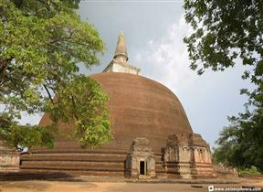
Visit Polonnaruwa, which was the 2nd capital city of Sri Lanka, built in the 11th and 12th centuries AD, and which is a world heritage site.. Here you can see the ruins of the Royal Palace, the Gal Viharaya where 4 splendid statues of the Buddha in 'Upright', 'Sedentary' and 'Recumbent' postures carved out of rock could be seen, the Audience Hall, the Lotus Bath, the statue of king Parakramabahu, and the Parakrama S amudraya, a lake built by King Parakramabahu the great. There are also monuments of famous places of worship such as the Shiva Temple, the Lankathilake, the Watadage, the Galpotha, the Kiri Vehera and the remains of a former Temple of the Tooth Relic. After excursion, return to the hotel.
Price : - 2pax - US$ 60.00 (per person)
Above 2pax - US$ 50.00 (per person)
* Discount of US$ 5.00, if pre-booked by clients at the time of the first booking.
Adventure - Optional excursion to a National Park for Safari
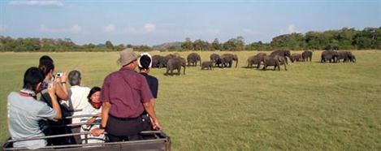
Do a safari of the Minneriya or Kaudulla or Eco National Park by jeep. The extent of the National Park is about 8,889 hectares. There are wet -lands in this National Park, which have international importance, animal and plant species, which are plenty in dry zone, are found in this park. Wild elephants , various amphibians, local and immigrant bird species are plenty in this park. About 160 species of birds, 09 amphibians, 25 reptile species, 26 fish species and more than 78 butterfly species have been found in this area. There are Bamboo trees, which are rare in other parks, and wild Elephants can be seen conveniently. The significant feature is that these elephants can be seen going closer to them. After excursion, return to the hotel
Price : - 2pax - US$ 70.00 (per person)
Above 2pax - US$ 60.00 (per person)
* Discount of US$ 5.00, if pre-booked by clients at the time of the first booking.

Dinner and overnight stay at hotel as per selected category.
DAY 03 : DAMBULLA or HABARANA or SIGIRIYA / DAMBULLA / MATALE / KANDY
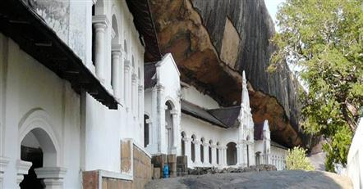
After breakfast leave for Kandy. En route visit Dambulla Rock Cave Temple was built by king Walagambahu in the 1st century B.C. and it is a World Heritage Site. It is the most impressive of Sri Lanka's cave temples. The complex of five caves with over 2000 sq. meters of painted walls and ceilings is the largest area of paintings found in the world. It contains over 150 images of the Buddha of which the largest is the colossal figure of the Buddha carved out of rock and spanning 14 metres.
Thereafter visit a spice garden in Matale to see different spices for which Sri Lanka is famous for. Here, clients could see different spices and how some of these spices are grown and processed. Witness a Cookery demonstration.
Proceed to Kandy and check in at hotel. Afternoon proceed on a city tour of Kandy. Kandy was the last capital of the Sri Lankan kings and is a World Heritage Site. The name "Kandy" conjures visions of splendour and magnificence. Many of the legends, traditions and folklore are still lovingly kept alive. Drive around the Kandy Lake built by the last Sinhala king, Sri Wickrama Rajasinghe in 1798. Visit the Kandy town and bazaar, the arts and crafts centre, a gem museum and a lapidary. Evening visit the Temple of the Tooth Relic in Kandy. Thereafter proceed to an auditorium to witness a cultural show.
Dinner and overnight stay at the hotel in Kandy.
DAY 04 : KANDY / PERADENIYA / PINNAWALA / SELECTED BEACH RESORT

After breakfast visit The Royal Botanical Garden in Peradeniya, which was first built as a pleasure garden by a Sinhala king and was expanded by the British. It is 147 acres in extent and provides an amazing variety of trees, plants and flowers.
On completion leave for your beach resort. En route visit The Elephant Orphange in Pinnawala, established in 1975, commenced with seven orphans. Today some of these orphans enjoy the fortune of seeing their grandchildren born in the same location. The original objective of establishing the orphanage inclined more towards tourism, but is soon became a conservation and educational centre. With the help of local and foreign elephant experts, Pinnawela started a scientific captive-breeding programme for elephants. The free movement of the herd enhanced the chances for respective individuals of both sexes to get together and mate. The nearby river played a dominant role in this regard, and in 1984, the first baby of Pinnawela was born. The success story of Pinnawela has drawn the attention of scientists from all over the world. A considerable number of books and research articles on Pinnawela have been published in several languages. The members of the Pinnawela herd have been filmed, videoed and photographed thousands of times by professionals.
Transfer from Pinnawala to Beach Hotel up to Beruwala from South and Marawila from North.
-Tour End-
- Tour Category - Standard
 | 02 pax. | 03 pax. | 04 pax. | 05-06 pax. | 07-12 pax. | 1 pax.
Accommodation on HB & Transportation with Russian speaking guide | 290.00 | 250.00 | 215.00 | 195.00 | 180.00 | 530.00
Entrance fees for sights | 91.00 | 91.00 | 91.00 | 91.00 | 91.00 | 91.00
Total package rate  (Accommodation + Transportation + Entrance fees) | 381.00 | 341.00 | 306.00 | 286.00 | 271.00 | 621.00

Single Supplement | USD 70.00
Peak period supplement (20/12/19 – 15/01/20) on DBL sharing  Peak period supplement (20/12/19 – 15/01/20) on SGL room | USD 05.00  USD 10.00

- Tour Category – Superior
 | 02 pax. | 03 pax. | 04 pax. | 05-06 pax. | 07-12 pax. | 1 pax.
Accommodation on HB & Transportation with Russian speaking guide | 320.00 | 275.00 | 240.00 | 215.00 | 200.00 | 595.00
Entrance fees for sights | 91.00 | 91.00 | 91.00 | 91.00 | 91.00 | 91.00
Total package rate  (Accommodation + Transportation + Entrance fees) | 411.00 | 366.00 | 331.00 | 306.00 | 291.00 | 686.00

Single Supplement | USD 85.00
Peak period supplement (20/12/19 – 15/01/20) on DBL sharing  Peak period supplement (20/12/19 – 15/01/20) on SGL room | USD 18.00  USD 30.00
Shoulder period supplement (16/01/20 – 31/03/20) on DBL sharing  Shoulder period supplement (16/01/20 – 31/03/20) on SGL room | USD 08.00  USD 10.00

- Tour Category – Deluxe
 | 02 pax. | 03 pax. | 04 pax. | 05-06 pax. | 07-12 pax. | 1 pax.
Accommodation on HB & Transportation with Russian speaking guide | 415.00 | 360.00 | 315.00 | 290.00 | 270.00 | 765.00
Entrance fees for sights | 91.00 | 91.00 | 91.00 | 91.00 | 91.00 | 91.00
Total package rate  (Accommodation + Transportation + Entrance fees) | 506.00 | 451.00 | 406.00 | 381.00 | 361.00 | 856.00

Single Supplement | USD 125.00
Peak period supplement (21/12/19 – 10/01/20) on DBL sharing  Peak period supplement (21/12/19 – 10/01/20) on SGL room | USD 87.00  USD 170.00
Shoulder period supplement (11/01/20 – 15/01/20) on DBL sharing  Shoulder period supplement (11/01/20 – 15/01/20) on SGL room | USD 52.00  USD 100.00
Shoulder period supplement (16/01/20 – 31/01/20) on DBL sharing  Shoulder period supplement (16/01/20 – 31/01/20) on SGL room | USD 47.00  USD 90.00
Shoulder period supplement (01/02/20 – 28/02/20) on DBL sharing  Shoulder period supplement (01/02/20 – 28/02/20) on SGL room | USD 52.00  USD 100.00
Shoulder period supplement (01/03/20 – 31/03/20) on DBL sharing  Shoulder period supplement (01/03/20 – 31/03/20) on SGL room | USD 15.00  USD 20.00
Shoulder period supplement (01/04/20 – 30/04/20) on DBL sharing  Shoulder period supplement (01/04/20 – 30/04/20) on SGL room | USD 05.00  USD 10.00
Supplement for Beach stay transfer beyond Bentota
Bentota - Induruwa - USD 6.00 per person
Bentota - Ahungalla - USD 11.00 per person
Bentota - Hikkaduwa - USD 16.00 per person
Bentota - Galle - USD 22.00 per person
Bentota - Koggala - USD 24.00 per person
Bentota - Weligama - USD 30.00 per person
Bentota - Dickwella - USD 38.00 per person
Bentota - Tangalle - USD 44.00 per person
Trincomalee drop - USD 60.00 per person

The above prices include:
- Accommodation in standard rooms on half board basis for 3 nights from dinner on day 1 to breakfast on day 4 at hotels specified or of similar standard.
- Transportation by air-conditioned vehicle from pick up at airport to drop off at Beach Hotel – up to Bentota (South) and Marawila (North).
- Services of a Russian Speaking National Guide.

Please note the Entrance fees for sights are shown separately. As per the clients’ choice, we can include it or exclude it from the package

Above prices does not include:
- Video Camera permits at Pinnawala Elephant Orphanage.
- Video Camera and Still Camera permits at the Temple of the Tooth Relic in Kandy.
- Lunch throughout the tour.
- Entrance fees to sites not specified above.
- Optional Excursions
- Cost of beverage and expenses of a personal nature throughout the tour.
- Tips and Porterage
- Any other services not specified above.
Programme : Exotic Lanka Special
Duration : 4 Days / 3 Nights.
Period/Dates : Winter 2019/20 (01st November 2019 to 30th April 2020)
___________________________________________________________________________________________
Tour Itinerary
DAY 01 : AIRPORT / COLOMBO
Arrival at Colombo International Airport where you will be met & welcome by our Tour Guide and transfer to Colombo. Check in at hotel.
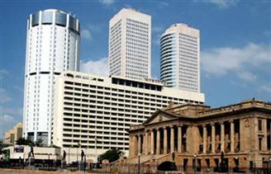
Afternoon proceed on at city tour of Colombo. In the afternoon, do a city tour of Colombo. Colombo like many capital cities in developing countries is fast changing its face. Almost overnight, skyscrapers arise from where old buildings once stood.Yet in some parts, the old world charm is retained. For example, there is a 100-year-old clock tower and several British built colonial buildings. Other places of interest are the Pettah bazaar – where one can shop for bargain, a Hindu and a Buddhist temple, residential areas where you find the stately homes of the affluent, the Bandaranaike Memorial International Conference Hall ( BMICH ) an outright gift to Sri Lanka from the People’s Republic of China.
Dinner and overnight stay at hotel in Colombo.
DAY 02 : COLOMBO / PINNAWALA / SIGIRIYA / DAMBULLA or HABARANA or SIGIRIYA

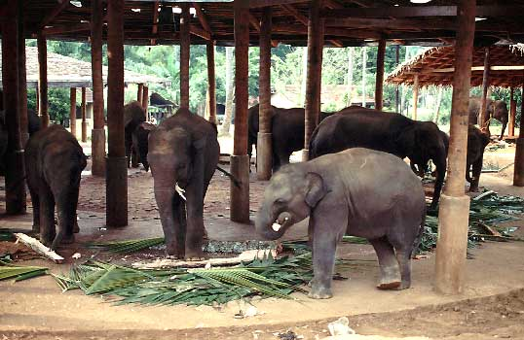
After breakfast proceed visit The Elephant Orpanage In Pinnawala, established in 1975,commenced with seven orphans. Today some of these orphans enjoy the fortune of seeing their grandchildren born in the same location. The original objective of establishing the orphanage inclined more towards tourism, but is soon became a conservation and educational centre. With help of local and foreign elephant experts, Pinnawela started a scientific captive breeding programme for elephants. The free movement of herd enhanced the chances for respective individuals of both sexes to get together and mate. The nearby river played a dominant role in this regard, and in 1984, the first baby of Pinnawela was born. The success story of Pinnawela has rawn he attention of scientists from all over the world. A considerable number of books and research articles on Pinnawela have been published in several languages. The members of the Pinnawela herd have been filmed, videoed and photographed thousands of times by professionals.
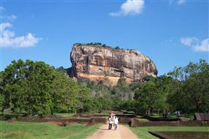
On completion proceed to Sigiriya and climb the 5th century Sigiriya rock fortress which is a world heritage site, built by King Kashyapa. The ‘Lion Rock’ is a citadel of unusual beauty rising 200 meters from the scrub jungle. The rock was the innermost stronghold of the 70 hectare fortified town. A moat, rampart, and extensive gardens including the renowned water gardens ring the base of the rock. Visit the world renowned frescoes of the ‘Heavenly Maidens’ of Sigiriya, which are in a sheltered pocket of the rock approached by a spiral stairway. The frescoes are painted in earth pigments on plaster.
Dinner and overnight stay at hotel as per selected category.
DAY 03 : DAMBULLA or HABARANA or SIGIRIYA / DAMBULLA / MATALE / KANDY

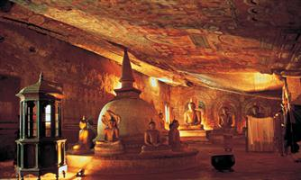
After breakfast leave for Kandy. En route visit Dambulla Rock Cave Temple which was built by king Walagambahu in the 1st century B.C. and it is a World Heritage Site. It is the most impressive of Sri Lanka’s cave temples. The complex of five caves with over 2000 sq. metres of painted walls and ceilings is the largest area of paintings found in the world. It contains over 150 images of the Buddha of which the largest is the colossal figure of the Buddha carved out of rock and spanning 14 meters.
Visit a spice garden in Matale to see different spices for which Sri Lanka is famous for. Here, clients could see different spices and how some of these spices are grown and processed. Witness a Cookery demonstration.
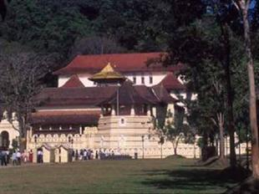
Proceed to a city tour of Kandy. Kandy was the last capital of the Sri Lankan kings and is a World Heritage Site.The name Kandy conjures visions of Splendor and magnificence. Many of the legends, traditions and folklore are still lovingly kept alive. Drive around the Kandy Lake built by the last Sinhala king, Sri Wickrama Rajasinghe in 1798. Visit the Kandy town and bazaar, the arts and crafts centre, a gem museum and a lapidary. Also visit the Temple of the Tooth Relic in Kandy. Thereafter proceed to an auditorium to witness a cultural show.
Dinner and overnight stay at hotel in Kandy
DAY 04 : KANDY / PERADENIYA / SELECTED BEACH RESORT

Breakfast at the hotel. Visit The Royal Botanical Garden in Peradeniya which was first built as a pleasure garden by a Sinhala king and was expanded by the British. It is 147 acres in extent and provides an amazing variety of trees, plants and flowers.
Transfer from Peradeniya to Beach Hotel up to Bentota from South and Marawila from North.
-Tour End-

- Tour Category – Standard
 | 02 pax. | 03 pax. | 04 pax. | 05-06 pax. | 07-12 pax. | 1 pax.
Accommodation on HB & Transportation with Russian speaking guide | 305.00 | 265.00 | 225.00 | 205.00 | 190.00 | 550.00
Entrance fees for sights | 91.00 | 91.00 | 91.00 | 91.00 | 91.00 | 91.00
Total package rate  (Accommodation + Transportation + Entrance fees) | 396.00 | 356.00 | 316.00 | 296.00 | 281.00 | 641.00

Single Supplement | USD 65.00
Peak period supplement (20/12/19 – 15/01/20) on DBL sharing  Peak period supplement (20/12/19 – 15/01/20) on SGL room | USD 05.00  USD 10.00

- Tour Category – Superior
 | 02 pax. | 03 pax. | 04 pax. | 05-06 pax. | 07-12 pax. | 1 pax.
Accommodation on HB & Transportation with Russian speaking guide | 340.00 | 300.00 | 255.00 | 235.00 | 215.00 | 635.00
Entrance fees for sights | 91.00 | 91.00 | 91.00 | 91.00 | 91.00 | 91.00
Total package rate  (Accommodation + Transportation + Entrance fees) | 431.00 | 391.00 | 346.00 | 326.00 | 306.00 | 726.00

Single Supplement | USD 90.00
Peak period supplement (20/12/19 – 15/01/20) on DBL sharing  Peak period supplement (20/12/19 – 15/01/20) on SGL room | USD 13.00  USD 20.00
Shoulder period supplement (16/01/20 – 31/03/20) on DBL sharing  Shoulder period supplement (16/01/20 – 31/03/20) on SGL room | USD 08.00  USD 10.00

- Tour Category – Deluxe
 | 02 pax. | 03 pax. | 04 pax. | 05-06 pax. | 07-12 pax. | 1 pax.
Accommodation on HB & Transportation with Russian speaking guide | 425.00 | 375.00 | 330.00 | 305.00 | 285.00 | 785.00
Entrance fees for sights | 91.00 | 91.00 | 91.00 | 91.00 | 91.00 | 91.00
Total package rate  (Accommodation + Transportation + Entrance fees) | 516.00 | 466.00 | 421.00 | 396.00 | 376.00 | 876.00

Single Supplement | USD 137.00
Peak period supplement (21/12/19 – 10/01/20) on DBL sharing  Peak period supplement (21/12/19 – 10/01/20) on SGL room | USD 87.00  USD 170.00
Shoulder period supplement (11/01/20 – 15/01/20) on DBL sharing  Shoulder period supplement (11/01/20 – 15/01/20) on SGL room | USD 52.00  USD 100.00
Shoulder period supplement (16/01/20 – 31/01/20) on DBL sharing  Shoulder period supplement (16/01/20 – 31/01/20) on SGL room | USD 47.00  USD 90.00
Shoulder period supplement (01/02/20 – 28/02/20) on DBL sharing  Shoulder period supplement (01/02/20 – 28/02/20) on SGL room | USD 52.00  USD 100.00
Shoulder period supplement (01/03/20 – 31/03/20) on DBL sharing  Shoulder period supplement (01/03/20 – 31/03/20) on SGL room | USD 20.00  USD 20.00
Shoulder period supplement (01/04/20 – 30/04/20) on DBL sharing  Shoulder period supplement (01/04/20 – 30/04/20) on SGL room | USD 05.00  USD 10.00

Supplement for Beach stay transfer beyond Bentota
Bentota - Induruwa - USD 6.00 per person
Bentota - Ahungalla - USD 11.00 per person
Bentota - Hikkaduwa - USD 16.00 per person
Bentota - Galle - USD 22.00 per person
Bentota - Koggala - USD 24.00 per person
Bentota - Weligama - USD 30.00 per person
Bentota - Dickwella - USD 38.00 per person
Bentota - Tangalle - USD 44.00 per person
Trincomalee drop - USD 60.00 per person

The above prices include:
- Accommodation in standard rooms on half board basis for 3 nights from dinner on day 1 to breakfast on day 4 at hotels specified or of similar standard.
- Transportation by air-conditioned vehicle from pick up at airport to drop off at Beach Hotel - up to Bentota (South) and Marawila (North).
- Service of a Russian Speaking National Guide.

Please note the Entrance fees for sights are shown separately. As per the clients’ choice, we can include it or exclude it from the package
Above prices does not include:
- Video Camera permits at Pinnawala Elephant Orphanage.
- Video Camera and Still Camera permits at the Temple of the Tooth Relic in Kandy.
- Lunch throughout the tour.
- Entrance fees to sites not specified above.
- Cost of beverage & expenses of a personal nature throughout the tour.
- Tips and Porterage
- Any other services not specified above.
Programme : Best of Sri Lanka
Duration : 4 Days / 3 Nights
Period/Dates : Winter 2019/20 (01st November 2019 to 30th April 2020)
________________________________________________________________________________________________________________________________________
Tour Itinerary
DAY 01 : AIRPORT / KANDY

Arrival at Colombo International Airport where you will be met & welcome by our Tour Guide and transfer to Kandy.
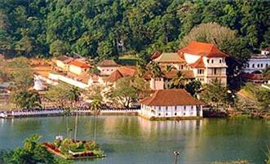
Proceed to a city tour of Kandy. Kandy was the last capital of the Sri Lankan kings and is a World Heritage Site. The name "Kandy" conjures visions of splendour and magnificence. Many of the legends, traditions and folklore are still lovingly kept alive. Drive around the Kandy Lake built by the last Sinhala king, Sri Wickrama Rajasinghe in 1798. Visit the Kandy town and bazaar, the arts and crafts centre, a gem museum and a lapidary.
Evening visit the Temple of the Tooth Relic in Kandy. Thereafter witness a cultural show.
Dinner and overnight stay at hotel in Kandy.
DAY 02 : KANDY / PERADENIYA / PINNAWALA / NUWARA ELIYA

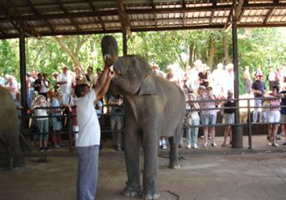
After breakfast visit The Royal Botanical Garden in Peradeniya which was first built as a pleasure garden by a Sinhala king and was expanded by the British It is 147 acres in extent and provides an amazing variety of trees, plants and flowers.
Transfer to Pinnawala. The Pinnawala Elephant Orphanage, established in 1975, commenced with Seven orphans. Today some of these orphans enjoy the Fortune of seeing their grandchildren born in the same location. Original objective of establishing the orphanage inclined more towards tourism, but is soon became a conservation and educational centre. With the help of local and foreign elephant experts, Pinnawela started a scientific captive - breeding programme for elephants. The free movement of the herd enhanced the chances for respective individuals of both sexes to get together and mate.
On completion leave for Nuwara Eliya. Check in at hotel.
Dinner and overnight stay at hotel in Nuwara Eliya.
DAY 03 : NUWARA ELIYA / YALA

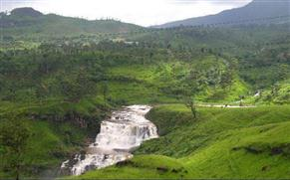
After breakfast visit Nuwara Eliya. Nuwara Eliya, because of its invigorating mountain climate and scenery, is Sri Lankas most popular hill resort. Nuwara Eliya is also the heart of Sri Lankas tea country producing a significant share of the world s best tea. Sri Lanka s highest mountain Pidurutalagala (8282 feet) is located here. Nuwara Eliya also has one of the finest 18 hole golf courses in South Asia.
On completion leave for Yala. Check in at hotel and rest of the day at leisure.
Dinner and overnight stay at hotel as per selected category.
DAY 04 : YALA / GALLE / SELECTED BEACH RESORT

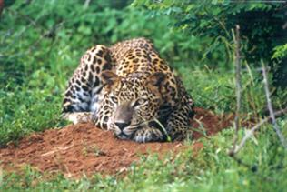
Morning proceed on an exciting jeep safari at Yala National Park. Elephant, Leopard, sloth bear, Spotted Dear, Wild Boar and sambhur. Apart from them small mammals such as Black naped hare, Grey, Ruddy & Striped necked mongoose, Grey Languor & porcupine are common small mammals. Park is also famous for its abundant bird life. Over 140 species have recorded so far within the park.
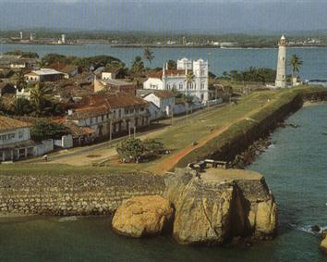
Thereafter transfer to your beach resort. En route visit Galle which was once the chief port of Ceylon. It is still well known for hand-made lace. You can also visit the Galle Fort (spanning 90 acres) which was originally built by the Portuguese and later extended by the Dutch in 1663. This is a World Heritage Site.
Transfer from Galle to Beach Hotel or up to Colombo.
-Tour End-
- Tour Category - Standard
 | 02 pax. | 03 pax. | 04 pax. | 05-06 pax. | 07-12 pax. | 1 pax.
Accommodation on HB & Transportation with Russian speaking guide | 335.00 | 290.00 | 245.00 | 220.00 | 200.00 | 620.00
Entrance fees for sights | 103.00 | 94.00 | 90.00 | 87.00 | 94.00 | 131.00
Total package rate  (Accommodation + Transportation + Entrance fees) | 438.00 | 384.00 | 335.00 | 307.00 | 294.00 | 751.00

Single Supplement | USD 78.00
Peak period supplement (20/12/19 – 15/01/20) on DBL sharing  Peak period supplement (20/12/19 – 15/01/20) on SGL room | USD 10.00  USD 20.00

- Tour Category – Superior
 | 02 pax. | 03 pax. | 04 pax. | 05-06 pax. | 07-12 pax. | 1 pax.
Accommodation on HB & Transportation with Russian speaking guide | 325.00 | 285.00 | 245.00 | 225.00 | 210.00 | 600.00
Entrance fees for sights | 103.00 | 94.00 | 90.00 | 87.00 | 94.00 | 131.00
Total package rate  (Accommodation + Transportation + Entrance fees) | 428.00 | 379.00 | 335.00 | 312.00 | 304.00 | 731.00

Single Supplement | USD 90.00
Peak period supplement (20/12/19 – 10/01/20) on DBL sharing  Peak period supplement (20/12/19 – 10/01/20) on SGL room | USD 15.00  USD 25.00
Shoulder period supplement (11/01/20 – 30/03/20) on DBL sharing  Shoulder period supplement (11/01/20 – 30/03/20) on SGL room | USD 08.00  USD 10.00

- Tour Category – Deluxe
 | 02 pax. | 03 pax. | 04 pax. | 05-06 pax. | 07-12 pax. | 1 pax.
Accommodation on HB & Transportation with Russian speaking guide | 525.00 | 458.00 | 415.00 | 380.00 | 360.00 | 990.00
Entrance fees for sights | 103.00 | 94.00 | 90.00 | 87.00 | 94.00 | 131.00
Total package rate  (Accommodation + Transportation + Entrance fees) | 628.00 | 552.00 | 505.00 | 467.00 | 454.00 | 1121.00

Single Supplement | USD 205.00
Shoulder period supplement (01/12/19 – 20/12/19) on DBL sharing  Shoulder period supplement (01/12/19 – 20/12/19) on SGL room | USD 08.00  USD 15.00
Peak period supplement (21/12/19 – 15/01/20) on DBL sharing  Peak period supplement (21/12/19 – 15/01/20) on SGL room | USD 50.00  USD 90.00
Peak period supplement (16/01/20 – 28/02/20) on DBL sharing  Peak period supplement (16/01/20 – 28/02/20) on SGL room | USD 45.00  USD 80.00
Shoulder period supplement (01/03/20 – 31/03/20) on DBL sharing  Shoulder period supplement (01/03/20 – 31/03/20) on SGL room | USD 35.00  USD 60.00
Shoulder period supplement (01/04/20 – 30/04/20) on DBL sharing  Shoulder period supplement (01/04/20 – 30/04/20) on SGL room | USD 25.00  USD 50.00
Supplement for Beach stay transfer beyond Colombo
Colombo – Negombo - USD 28.00 per person
Colombo – Marawila - USD 34.00 per person
Trincomalee drop - USD 80.00 per person

The above prices include:
- Accommodation in standard rooms on half board basis for 6 nights from dinner on day 1 to breakfast on day 7 at hotels specified or of similar standard.
- Transportation by air-conditioned vehicle from pick up at airport to drop off in Colombo (Departure transfer is not included)
- Services of a Russian Speaking National Guide.

Please note the Entrance fees for sights are shown separately. As per the clients’ choice, we can include it or exclude it from the package

Above prices does not include:
- Video Camera permits at Pinnawala Elephant Orphanage.
- Video Camera and Still Camera permits at the Temple of the Tooth Relic in Kandy.
- Lunch throughout the tour.
- Entrance fees to sites not specified above.
- Cost of beverage & expenses of a personal nature throughout the tour.
Programme : Cultural Experience
Duration : 5 Days / 4 Nights
Period/Dates : Winter 2019/20 (01st November 2019 to 30th April 2020)
_________________________________________________________________________________________________________________

Tour Itinerary
DAY 01 : AIRPORT / DAMBULLA or HABARANA or SIGIRIYA

Arrival at Colombo International Airport where you will be met & welcome by our Tour Guide and transfer to Dambulla. Check in at hotel.
Dinner & overnight stay at hotel as per selected category.
DAY 02 : SIGIRIYA

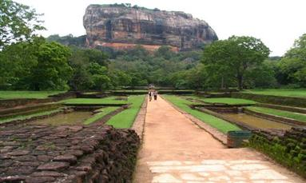
Breakfast at the hotel. Proceed to Sigiriya and climb the 5th century Sigiriya rock fortress which is a world heritage site, built by King Kashyapa (477-495 AD). The 'Lion Rock' is a citadel of unusual beauty rising 200 meters from the scrub jungle. The rock was the innermost stronghold of the 70 hectare fortified town. A moat, rampart, and extensive gardens including the renowned water gardens ring the base of the rock. Visit the world-renowned frescoes of the 'Heavenly Maidens' of Sigiriya, which are in a sheltered pocket of the rock approached by a spiral stairway. These frescoes are painted in earth pigments on plaster.
Return to the hotel or do an optional excursion in the afternoon.
Culture - Optional excursion to Polonnaruwa
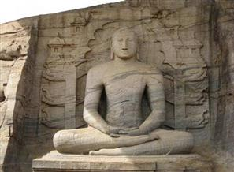
Visit Polonnaruwa, which was the 2nd capital city of Sri Lanka, built in the 11th and 12th centuries AD, and which is a world heritage site. Here you can see the ruins of the Royal Palace, the Gal Viharaya where 4 splendid statues of the Buddha in 'Upright', 'Sedentary' and 'Recumbent' postures carved out of rock could be seen, the Audience Hall, the Lotus Bath, the statue of king Parakramabahu, and the Parakrama Samudraya a lake built by King Parakramabahu the great. There are also monuments of famous places of worship such as the Shiva Temple, the Lankathilake, the Watadage, the Galpotha, the Kiri Vehera and the remains of a former Temple of the Tooth Relic. After excursion, return to the hotel.
Price : - 2pax - US$ 60.00 (per person)
Above 2pax - US$ 50.00 (per person)
* Discount of US$ 5.00, if pre-booked by clients at the time of the first booking.

Adventure - Optional excursion to a National Park for Safari
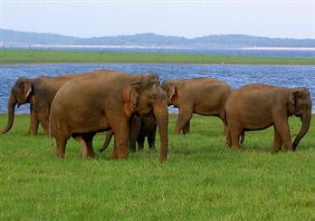
Do a safari of the Minneriya OR Kaudulla OR Eco National Park by jeep. The extent of the National Park is about 8,889 hectares. There are wet - lands in this National Park, which have international importance, animal and plant species which are plenty in dry zone, are found in this park. Wild elephants, various amphibians, local and immigrant bird species are plenty in his park. About 160 species of birds, 09 amphibians, 25 reptile species, 26 fish species and more than 78 butterfly species have been found in this area. There are bamboo trees, which are rare in other parks, and wild elephants can be seen conveniently. The significant feature is that these elephants can be seen going closer to them. After excursion, return to the hotel.
Price : - 2pax - US$ 70.00 (per person)
Above 2pax - US$ 60.00 (per person)
* Discount of US$ 5.00, if pre-booked by clients at the time of the first booking.

Dinner & overnight stay at hotel as per selected category.
DAY 03 : DAMBULLA or HABARANA or SIGIRIYA / DAMBULLA / MATALE / KANDY
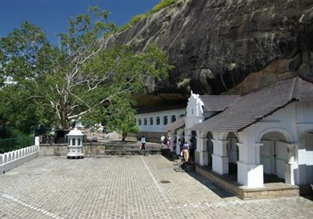
After breakfast leave for Kandy. En route visit Dambulla rock cave temple which was built by king Walagambahu in the 1st century B.C. and it is a World Heritage Site. It is the most impressive of Sri Lanka's cave temples. The complex of five caves with over 2000 sq. meters of painted walls and ceilings is the largest area of paintings found in the world. It contains over 150 images of the Buddha of which the largest is the colossal figure of the Buddha carved out of rock and spanning 14 meters.
Also visit a spice garden in Matale to see different spices for which Sri Lanka is famous for. Here, clients could see different spices and how some of these spices are grown and processed. Witness a Cookery demonstration. Proceed to Kandy.
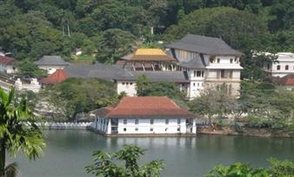
Proceed to a city tour of Kandy. Kandy was the last capital of the Sri Lankan kings and is a World Heritage Site. The name "Kandy" conjures visions of splendor and magnificence. Many of the legends, traditions and folklore are still lovingly kept alive. Drive around the Kandy Lake built by the last Sinhala king, Sri Wickrama Rajasinghe in 1798. Visit the Kandy town and bazaar, the arts and crafts centre, a gem museum and a lapidary. Also visit the Temple of the Tooth Relic in Kandy. Thereafter witness a cultural show.
Dinner and overnight stay at hotel in Kandy.
DAY 04 : KANDY / PERADENIYA / PINNAWALA / COLOMBO

After breakfast proceed to visit The Royal Botanical Garden in Peradeniya. The botanical garden was first built as a pleasure garden by a Sinhala king and was expanded by the British. It is 147 acres in extent and provides an amazing variety of trees, plants and flowers.
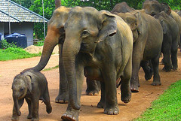
On completion leave for Colombo. En route visit Elephant Orphanage in Pinnawala established in 1975, Commenced with seven orphans. Today some of these orphans enjoy the fortune of seeing their grandchildren born in the same location. The original objective of establishing the orphanage inclined more towards tourism, but is soon became a conservation and educational centre. With the help of local and foreign elephant experts, Pinnawela started a scientific captive - breeding programme for elephants. The free movement of the herd enhanced the chances for respective individuals of both sexes to get together and mate. The nearby river played a dominant role in this regard, and in 1984, the first baby of Pinnawela was born. The success story of Pinnawela has drawn the attention of scientists from all over the world. A considerable number of books and research articles on Pinnawela have been published in several languages. The members of the Pinnawela herd have been filmed, videoed and photographed thousands of times by professionals.
Dinner and overnight stay at hotel in Colombo.
DAY 05 : COLOMBO / AIRPORT or BEACH RESORT

Breakfast at the hotel. Transfer to Airport or up to Bentota (from South) or Marawila (from North)
-Tour End-
- Tour Category - Standard
 | 02 pax. | 03 pax. | 04 pax. | 05-06 pax. | 07-12 pax. | 1 pax.
Accommodation on HB & Transportation with Russian speaking guide | 345.00 | 300.00 | 260.00 | 240.00 | 220.00 | 620.00
Entrance fees for sights | 91.00 | 91.00 | 91.00 | 91.00 | 91.00 | 91.00
Total package rate  (Accommodation + Transportation + Entrance fees) | 436.00 | 391.00 | 351.00 | 331.00 | 311.00 | 711.00

Single Supplement | USD 82.00
Peak period supplement (20/12/19 – 15/01/20) on DBL sharing  Peak period supplement (20/12/19 – 15/01/20) on SGL room | USD 10.00  USD 20.00

- Tour Category – Superior
 | 02 pax. | 03 pax. | 04 pax. | 05-06 pax. | 07-12 pax. | 1 pax.
Accommodation on HB & Transportation with Russian speaking guide | 400.00 | 345.00 | 305.00 | 280.00 | 260.00 | 730.00
Entrance fees for sights | 91.00 | 91.00 | 91.00 | 91.00 | 91.00 | 91.00
Total package rate  (Accommodation + Transportation + Entrance fees) | 491.00 | 436.00 | 396.00 | 371.00 | 351.00 | 821.00

Single Supplement | USD 116.00
Peak period supplement (20/12/19 – 15/01/20) on DBL sharing  Peak period supplement (20/12/19 – 15/01/20) on SGL room | USD 18.00  USD 30.00
Shoulder period supplement (16/01/20 – 31/03/20) on DBL sharing  Shoulder period supplement (16/01/20 – 31/03/20) on SGL room | USD 08.00  USD 10.00

- Tour Category – Deluxe
 | 02 pax. | 03 pax. | 04 pax. | 05-06 pax. | 07-12 pax. | 1 pax.
Accommodation on HB & Transportation with Russian speaking guide | 525.00 | 460.00 | 415.00 | 385.00 | 360.00 | 960.00
Entrance fees for sights | 91.00 | 91.00 | 91.00 | 91.00 | 91.00 | 91.00
Total package rate  (Accommodation + Transportation + Entrance fees) | 612.00 | 549.00 | 501.00 | 473.00 | 454.00 | 1047.00

Single Supplement | USD 180.00
Peak period supplement (21/12/19 – 10/01/20) on DBL sharing  Peak period supplement (21/12/19 – 10/01/20) on SGL room | USD 87.00  USD 170.00
Peak period supplement (11/01/20 –15/01/20) on DBL sharing  Peak period supplement (11/01/20 –15/01/20) on SGL room | USD 52.00  USD 100.00
Shoulder period supplement (16/01/20 – 31/01/20) on DBL sharing  Shoulder period supplement (16/01/20 – 31/01/20) on SGL room | USD 47.00  USD 90.00
Shoulder period supplement (01/02/20 – 28/02/20) on DBL sharing  Shoulder period supplement (01/02/20 – 28/02/20) on SGL room | USD 52.00  USD 100.00
Shoulder period supplement (01/03/20 – 31/03/20) on DBL sharing  Shoulder period supplement (01/03/20 – 31/03/20)) on SGL room | USD 20.00  USD 20.00
Shoulder period supplement (01/04/20 – 30/04/20) on DBL sharing  Shoulder period supplement (01/04/20 – 30/04/20) on SGL room | USD 05.00  USD 10.00

Supplement for Beach stay transfer beyond Bentota
Bentota - Induruwa - USD 6.00 per person
Bentota - Ahungalla - USD 11.00 per person
Bentota - Hikkaduwa - USD 16.00 per person
Bentota - Galle - USD 22.00 per person
Bentota - Koggala - USD 24.00 per person
Bentota - Weligama - USD 30.00 per person
Bentota - Dickwella - USD 38.00 per person
Bentota - Tangalle - USD 44.00 per person
Trincomalee drop - USD 80.00 per person

The above prices include:
- Accommodation in standard rooms on half board basis for 4 nights from dinner on day 1 to breakfast on day 5 at hotels specified or of similar standard.
- Transportation by air-conditioned vehicle from pick up at airport to drop off at airport OR to Bentota (South) or to Marawila (North).
- Service of Russian Speaking National Guide.

Please note the Entrance fees for sights are shown separately. As per the clients’ choice, we can include it or exclude it from the package

Above prices does not include:
- Video Camera permits at Pinnawala Elephant Orphanage.
- Video Camera and Still Camera permits at the Temple of the Tooth Relic in Kandy.
- Lunch throughout the tour.
- Entrance fees to sites not specified above and optional excursions
- Cost of beverage & expenses of a personal nature throughout the tour.
- Tips and Porterage
- Any other services not specified above.
Programme : Explore the Paradise Island
Duration : 5 Days / 4 Nights
Period/Dates : Winter 2019/20 (01st November 2019 to 30th April 2020)
_________________________________________________________________________________________________________________
Tour Itinerary
DAY 01 : AIRPORT / DAMBULLA or HABARANA or SIGIRIYA

Arrival at Colombo International Airport where you will be met & welcome by our Tour Guide and transfer to Dambulla. Check in at hotel.
Dinner & overnight stay at hotel as per selected category.
DAY 02 : SIGIRIYA / MINNERIYA

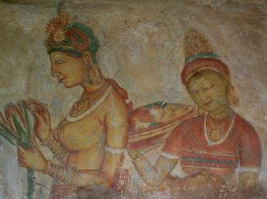
After breakfast proceed to Sigiriya and climb the 5th century Sigiriya rock fortress which is a world heritage site. Built by King Kashyapa (477-495 AD). The 'Lion Rock' is a citadel of unusual beauty rising 200 meters from the scrub jungle. The rock was the innermost stronghold of the 70 hectare fortified town. A moat, rampart, and extensive gardens including the renowned water gardens ring the base of the rock. Visit the world-renowned frescoes of the 'Heavenly Maidens' of Sigiriya, which are in a sheltered pocket of the rock approached by a spiral stairway. These frescoes are painted in earth pigments on plaster.
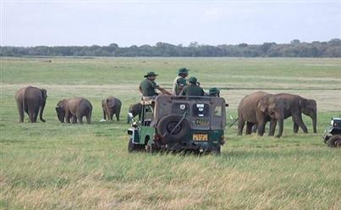
Afternoon proceed an exciting jeep safari at the Minneriya / Kaudulla / Eco National Park by jeep. The extent of the National Park is about 8,889 hectares. There are wet-lands in this National Park, which have international importance, animal and plant species, which are plenty in dry zone, are found in this park. Wild elephants, various amphibians, local and immigrant bird species are plenty in this park. About 160 species of birds, 09 amphibians, 25 reptile species, 26 fish species and more than 78 butterfly species have been found in this area. There are bamboo trees, which are rare in other parks, and wild elephants can be seen conveniently. The significant feature is that these elephants can be seen going closer to them.
Dinner & overnight stay at hotel as per selected category.
DAY 03 : DAMBULLA or HABARANA or SIGIRIYA / DAMBULLA / MATALE / KANDY

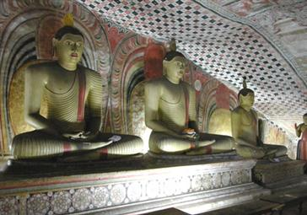
After breakfast leave for Kandy. En route visit Dambulla Rock Cave temple which was built by king Walagambahu in the 1st century B.C. and it is a World Heritage Site. It is the most impressive of Sri Lanka's cave temples.The Complex of five caves with over 2000 sq. meters of Painted walls and ceilings is the largest area of paintings found in the world. It contains over 150 images of the Buddha of which the largest is the colossal figure of Buddha carved out of rock and spanning 14 meters.
Visit a spice garden in Matale to see different spices for which Sri Lanka is famous for. Here, clients could see different spices and how some of these spices are grown and processed. Witness a Cookery demonstration.
Proceed to a city tour of Kandy. Kandy was the last capital of the Sri Lankan kings and is a World Heritage Site. The name "Kandy" conjures visions of splendor and magnificence. Many of the legends, traditions and folklore are still lovingly kept alive. Drive around the Kandy Lake built by the last Sinhala king, Sri Wickrama Rajasinghe in 1798. Visit the Kandy town and bazaar, the arts and crafts centre, a gem museum and a lapidary. Also visit the Temple of the Tooth Relic in Kandy. Thereafter witness a cultural show.
Dinner and overnight stay at hotel in Kandy.
DAY 04 : KANDY / PERADENIYA / PINNAWALA / NUWARA ELIYA
After breakfast visit The Royal Botanical Garden which was first built as a pleasure garden by a Sinhala king and was expanded by the British. It is 147 acres in extent and provides an amazing variety of trees, plants and flowers.
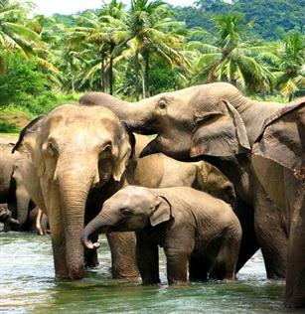
Thereafter proceed to visit The Elephant Orphanage in Pinnawala, established in 1975, Commenced with seven orphans. Today some of these orphans enjoy the fortune of seeing their grandchildren born in the same location. The original objective of establishing the orphanage inclined more towards tourism, but is soon became a conservation and educational centre. With the help of local and foreign elephant experts, Pinnawela started a scientific captive – breeding programme for elephants. The free movement of the herd enhanced the chances for respective individuals of both sexes to get together and mate. The nearby river played a dominant role in this regard, and in 1984, the first baby of Pinnawela was born. The success story of Pinnawela has drawn the attention of scientists from all over the world.
On completion leave for Nuwara Eliya and check in at hotel.
Dinner and overnight stay at hotel in Nuwara Eliya.
DAY 05 : NUWARA ELIYA / KITULGALA / SELECTED BEACH RESORT

After breakfast visit Nuwara Eliya. Nuwara Eliya, because of its invigorating mountain climate and scenery, is Sri Lankas most popular hill resort. Nuwara Eliya is also the heart of Sri Lankas tea country producing a significant share of the world s best tea. Sri Lanka s highest mountain Pidurutalagala (8282 feet) is located here. Nuwara Eliya also has one of the finest 18 hole golf courses in South Asia. On completion transfer to Beach resort via Kitulgala. The Kelani River (the broadest river in Sri Lanka ) flowing through Kitulgala was the main location where the Oscar winning movie “Bridge on the River Kwai” was filmed. On the hill above this town, a prehistoric cave was recently discovered containing large middens of shells from some unknown civilization.
Adventure - Optional excursion in Kitulgala – River rafting for 45 minutes
Price : - 2pax - US$ 45.00 (per person)
Above 2pax - US$ 35.00 (per person)
* Discount of US$ 5.00, if pre-booked by clients at the time of the first booking.
Transfer from Nuwara Eliya to Beach Resort up to Beruwala from South and Marawila from North.
-Tour End-
- Tour Category - Standard
 | 02 pax. | 03 pax. | 04 pax. | 05-06 pax. | 07-12 pax. | 1 pax.
Accommodation on HB & Transportation with Russian speaking guide | 395.00 | 340.00 | 295.00 | 265.00 | 245.00 | 730.00
Entrance fees for sights | 130.00 | 125.00 | 124.00 | 123.00 | 125.00 | 140.00
Total package rate  (Accommodation + Transportation + Entrance fees) | 525.00 | 465.00 | 419.00 | 388.00 | 370.00 | 870.00

Single Supplement | USD 95.00
Peak period supplement (20/12/19 – 15/01/20) on DBL sharing  Peak period supplement (20/12/19 – 15/01/20) on SGL room | USD 10.00  USD 20.00

- Tour Category – Superior
 | 02 pax. | 03 pax. | 04 pax. | 05-06 pax. | 07-12 pax. | 1 pax.
Accommodation on HB & Transportation with Russian speaking guide | 445.00 | 390.00 | 340.00 | 310.00 | 285.00 | 815.00
Entrance fees for sights | 130.00 | 125.00 | 124.00 | 123.00 | 125.00 | 140.00
Total package rate  (Accommodation + Transportation + Entrance fees) | 575.00 | 515.00 | 464.00 | 433.00 | 410.00 | 955.00

Single Supplement | USD 121.00
Peak period supplement (20/12/198 – 15/01/20) on DBL sharing  Peak period supplement (20/12/198 – 15/01/20) on SGL room | USD 18.00  USD 30.00
Shoulder period supplement (16/01/20 – 31/03/20) on DBL sharing  Shoulder period supplement (16/01/20 – 31/03/20) on SGL room | USD 08.00  USD 10.00

- Tour Category – Deluxe
 | 02 pax. | 03 pax. | 04 pax. | 05-06 pax. | 07-12 pax. | 1 pax.
Accommodation on HB & Transportation with Russian speaking guide | 575.00 | 505.00 | 450.00 | 415.00 | 385.00 | 1,060.00
Entrance fees for sights | 130.00 | 125.00 | 124.00 | 123.00 | 125.00 | 140.00
Total package rate  (Accommodation + Transportation + Entrance fees) | 705.00 | 630.00 | 574.00 | 538.00 | 510.00 | 1,200.00

Single Supplement | USD 190.00
Shoulder period supplement (01/12/19 – 20/12/19) on DBL sharing  Shoulder period supplement (01/12/19 – 20/12/19) on SGL room | USD 08.00  USD 15.00
Peak period supplement (21/12/19 – 10/01/20) on DBL sharing  Peak period supplement (21/12/19 – 10/01/20) on SGL room | USD 95.00  USD 185.00
Peak period supplement (11/01/20 – 15/01/20) on DBL sharing  Peak period supplement (11/01/20 – 15/01/20) on SGL room | USD 60.00  USD 115.00
Shoulder period supplement (16/01/20 – 31/01/20) on DBL sharing  Shoulder period supplement (16/01/20 – 31/01/20) on SGL room | USD 55.00  USD 105.00
Shoulder period supplement (01/02/20 – 28/02/20) on DBL sharing  Shoulder period supplement (01/02/20 – 28/02/20) on SGL room | USD 60.00  USD 115.00
Shoulder period supplement (01/03/20 – 31/03/20) on DBL sharing  Shoulder period supplement (01/03/20 – 31/03/20) on SGL room | USD 23.00  USD 35.00
Shoulder period supplement (01/04/20 –30/04/20) on DBL sharing  Shoulder period supplement (01/04/20 –30/04/20) on SGL room | USD 13.00  USD 25.00
Supplement for Beach stay transfer beyond Bentota
Bentota - Induruwa - USD 6.00 per person
Bentota - Ahungalla - USD 11.00 per person
Bentota - Hikkaduwa - USD 16.00 per person
Bentota - Galle - USD 22.00 per person
Bentota - Koggala - USD 24.00 per person
Bentota - Weligama - USD 30.00 per person
Bentota - Dickwella - USD 38.00 per person
Bentota - Tangalle - USD 44.00 per person
Trincomalee drop - USD 75.00 per person

The above prices include:
- Accommodation in standard rooms on half board basis for 4 nights from dinner on day 1 to breakfast on day 5 at hotels specified or of similar standard.
- Transportation by air-conditioned vehicle from pick up at airport to drop off at beach Hotel up to Beruwala (South).
- Services of Russian Speaking National Guide.

Please note the Entrance fees for sights are shown separately. As per the clients’ choice, we can include it or exclude it from the package

Above prices does not include:
- Video Camera permits at Pinnawala Elephant Orphanage.
- Video Camera and Still Camera permits at the Temple of the Tooth Relic in Kandy.
- Lunch throughout the tour.
- Entrance fees to sites not specified above and optional Excursions
- Cost of beverage & expenses of a personal nature throughout the tour.
- Tips and Porterage
Programme : Wonders of Ceylon
Duration : 6 Days / 5 Nights
Period/Dates : Winter 2019/20 (01st November 2019 to 30th April 2020)
_________________________________________________________________________________________________________________
Tour Itinerary
DAY 01 : AIRPORT / COLOMBO

Arrival at Colombo International Airport where you will be met & welcome by our Tour Guide and transfer to Colombo. Check in at hotel.
Dinner & overnight stay at hotel in Colombo.
DAY 02 : COLOMBO / PINNAWALA / DAMBULLA or HABARANA or SIGIRIYA

After breakfast proceed on a city tour of Colombo. Colombo like many capital cities in developing countries is fast changing its face. Almost overnight, skyscrapers arise from where old buildings once stood.Yet in some parts, the old world charm is retained. For example, there is a 100-year-old clock tower and several British built colonial buildings. Other places of interest are the Pettah bazaar – where one can shop for bargain, a Hindu and a Buddhist temple, residential areas where you find the stately homes of the affluent, the Bandaranaike Memorial International Conference Hall an outright gift to Sri Lanka from the People’s Republic of China.
Thereafter proceed to visit The Elephant Orphanage in Pinnawala, established in 1975, Commenced with seven orphans. Today some of these orphans enjoy the fortune of seeing their grandchildren born in the same location. The original objective of establishing the orphanage inclined more towards tourism, but is soon became a conservation and educational centre. With the help of local and foreign elephant experts, Pinnawela started a scientific captive – breeding programme for elephants. The free movement of the herd enhanced the chances for respective individuals of both sexes to get together and mate. The nearby river played a dominant role in this regard, and in 1984, the first baby of Pinnawela was born. The success story of Pinnawela has drawn the attention of scientists from all over the world.
Transfer to Dambulla.
Dinner & overnight stay at hotel as per selected category.
DAY 03 : SIGIRIYA / MINNERIYA

After breakfast proceed to Sigiriya and climb the 5th century Sigiriya rock fortress which is a world heritage site. Built by King Kashyapa (477-495 AD). The 'Lion Rock' is a citadel of unusual beauty rising 200 meters from the scrub jungle. The rock was the innermost stronghold of the 70 hectare fortified town. A moat, rampart, and extensive gardens including the renowned water gardens ring the base of the rock. Visit the world-renowned frescoes of the 'Heavenly Maidens' of Sigiriya, which are in a sheltered pocket of the rock approached by a spiral stairway. These frescoes are painted in earth pigments on plaster.
Afternoon proceed an exciting jeep safari at the Minneriya National Park by jeep. The extent of the National Park is about 8,889 hectares. There are wet-lands in this National Park, which have international importance, animal and plant species, which are plenty in dry zone, are found in this park. Wild elephants, various amphibians, local and immigrant bird species are plenty in this park. About 160 species of birds, 09 amphibians, 25 reptile species, 26 fish species and more than 78 butterfly species have been found in this area. There are bamboo trees, which are rare in other parks, and wild elephants can be seen conveniently. The significant feature is that these elephants can be seen going closer to them.
Dinner & overnight stay at hotel as per selected category.

DAY 04 : DAMBULLA or HABARANA or SIGIRIYA / DAMBULLA / MATALE / KANDY
After breakfast leave for Kandy. En route visit Dambulla Rock Cave temple which was built by king Walagambahu in the 1st century B.C. and it is a World Heritage Site. It is the most impressive of Sri Lanka's cave temples.The Complex of five caves with over 2000 sq. meters of Painted walls and ceilings is the largest area of paintings found in the world. It contains over 150 images of the Buddha of which the largest is the colossal figure of Buddha carved out of rock and spanning 14 meters.
Visit a spice garden in Matale to see different spices for which Sri Lanka is famous for. Here, clients could see different spices and how some of these spices are grown and processed. Witness a Cookery demonstration.
Proceed to a city tour of Kandy. Kandy was the last capital of the Sri Lankan kings and is a World Heritage Site. The name "Kandy" conjures visions of splendor and magnificence. Many of the legends, traditions and folklore are still lovingly kept alive. Drive around the Kandy Lake built by the last Sinhala king, Sri Wickrama Rajasinghe in 1798. Visit the Kandy town and bazaar, the arts and crafts centre, a gem museum and a lapidary.
Evening visit the Temple of the Tooth Relic in Kandy. Thereafter witness a cultural show.
Dinner and overnight stay at hotel in Kandy.
DAY 05 : KANDY / PERADENIYA / NUWARA ELIYA
After breakfast visit The Royal Botanical Garden which was first built as a pleasure garden by a Sinhala king and was expanded by the British. It is 147 acres in extent and provides an amazing variety of trees, plants and flowers.
On completion leave for Nuwara Eliya.
Do a city tour of Nuwara Eliya, because of its invigorating mountain climate and scenery, is Sri Lankas most popular hill resort. Nuwara Eliya is also the heart of Sri Lankas tea country producing a significant share of the world s best tea. Sri Lanka s highest mountain Pidurutalagala (8282 feet) is located here. Nuwara Eliya also has one of the finest 18 hole golf courses in South Asia. On completion transfer to Beach resort via Kitulgala. The Kelani River (the broadest river in Sri Lanka ) flowing through Kitulgala was the main location where the Oscar winning movie “Bridge on the River Kwai” was filmed. On the hill above this town, a prehistoric cave was recently discovered containing large middens of shells from some unknown civilization.
Dinner and overnight stay at hotel in Nuwara Eliya.
DAY 06 : NUWARA ELIYA / HORTON PLAINS / SELECTED BEACH RESORT

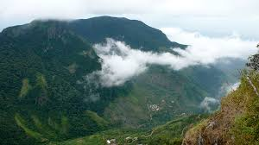
Early morning visit Horton plains, which is located on a high windswept saddle at about 2134 meters above the sea level. The plains are an expanse of misty grassland with scraggy trees and ice-cold rivulets. Visit the World s End, considered tobe the finest view in all of Sri Lanka. The awesome escarpment drops vertically for about 4,000 feet, hence its name. You can also see the beautiful Backer s falls. (Walk is about 14 km). The park shelters mammals such as Sambhur, Leopard and endemic Bear Monkey and famous for its endemic lizards. This area is a home for over 20 endemic bird species including Sri Lanka Whistling Thrush, Orange-billed Babbler and Yellow-eared Bulbul.
Transfer to Beach Resort up to Beruwala from South and Marawila from North.
-Tour End-
- Tour Category - Standard
 | 02 pax. | 03 pax. | 04 pax. | 05-06 pax. | 07-12 pax. | 1 pax.
Accommodation on HB & Transportation with Russian speaking guide | 465.00 | 405.00 | 355.00 | 320.00 | 295.00 | 845.00
Entrance fees for sights | 172.00 | 163.00 | 158.00 | 156.00 | 163.00 | 198.00
Total package rate  (Accommodation + Transportation + Entrance fees) | 637.00 | 568.00 | 513.00 | 476.00 | 458.00 | 1,043.00

Single Supplement | USD 110.00
Peak period supplement (20/12/19 – 15/01/20) on DBL sharing  Peak period supplement (20/12/19 – 15/01/20) on SGL room | USD 10.00  USD 20.00

- Tour Category – Superior
 | 02 pax. | 03 pax. | 04 pax. | 05-06 pax. | 07-12 pax. | 1 pax.
Accommodation on HB & Transportation with Russian speaking guide | 535.00 | 470.00 | 415.00 | 380.00 | 355.00 | 975.00
Entrance fees for sights | 172.00 | 163.00 | 158.00 | 156.00 | 163.00 | 198.00
Total package rate  (Accommodation + Transportation + Entrance fees) | 707.00 | 633.00 | 573.00 | 536.00 | 518.00 | 1,173.00

Single Supplement | USD 155.00
Peak period supplement (20/12/19 – 15/01/20) on DBL sharing  Peak period supplement (20/12/19 – 15/01/20) on SGL room | USD 18.00  USD 30.00
Shoulder period supplement (16/01/20 – 31/03/20) on DBL sharing  Shoulder period supplement (16/01/20 – 31/03/20) on SGL room | USD 08.00  USD 10.00

- Tour Category – Deluxe
 | 02 pax. | 03 pax. | 04 pax. | 05-06 pax. | 07-12 pax. | 1 pax.
Accommodation on HB & Transportation with Russian speaking guide | 700.00 | 615.00 | 550.00 | 510.00 | 480.00 | 1280.00
Entrance fees for sights | 172.00 | 163.00 | 158.00 | 156.00 | 163.00 | 198.00
Total package rate  (Accommodation + Transportation + Entrance fees) | 872.00 | 778.00 | 708.00 | 666.00 | 643.00 | 1,478.00

Single Supplement | USD 245.00
Shoulder period supplement (01/12/19 – 20/12/19) on DBL sharing  Shoulder period supplement (01/12/19 – 20/12/19) on SGL room | USD 08.00  USD 15.00
Peak period supplement (21/12/19 – 10/01/20) on DBL sharing  Peak period supplement (21/12/19 – 10/01/20) on SGL room | USD 95.00  USD 185.00
Peak period supplement (11/01/20 – 15/01/20) on DBL sharing  Peak period supplement (11/01/20 – 15/01/20) on SGL room | USD 60.00  USD 115.00
Peak period supplement (16/01/20 – 31/01/20) on DBL sharing  Peak period supplement (16/01/20 – 31/01/20) on SGL room | USD 55.00  USD 105.00
Peak period supplement (01/02/20 – 28/02/20) on DBL sharing  Peak period supplement (01/02/20 – 28/02/20) on SGL room | USD 60.00  USD 115.00
Shoulder period supplement (01/03/20 – 31/03/20) on DBL sharing  Shoulder period supplement (01/03/20 – 31/03/20) on SGL room | USD 23.00  USD 35.00
Shoulder period supplement (01/04/20 – 30/04/20) on DBL sharing  Shoulder period supplement (01/04/20 – 30/04/20) on SGL room | USD 13.00  USD 25.00
Supplement for Beach stay transfer beyond Bentota
Bentota - Induruwa - USD 6.00 per person
Bentota - Ahungalla - USD 11.00 per person
Bentota - Hikkaduwa - USD 16.00 per person
Bentota - Galle - USD 22.00 per person
Bentota - Koggala - USD 24.00 per person
Bentota - Weligama - USD 30.00 per person
Bentota - Dickwella - USD 38.00 per person
Bentota - Tangalle - USD 44.00 per person
Trincomalee drop - USD 75.00 per person

The above prices include:
- Accommodation in standard rooms on half board basis for 4 nights from dinner on day 1 to breakfast on day 5 at hotels specified or of similar standard.
- Transportation by air-conditioned vehicle from pick up at airport to drop off at beach Hotel up to Beruwala (South).
- Services of Russian Speaking National Guide.

Please note the Entrance fees for sights are shown separately. As per the clients’ choice, we can include it or exclude it from the package

Above prices does not include:
- Video Camera permits at Pinnawala Elephant Orphanage.
- Video Camera and Still Camera permits at the Temple of the Tooth Relic in Kandy.
- Lunch throughout the tour.
- Entrance fees to sites not specified above and optional Excursions
- Cost of beverage & expenses of a personal nature throughout the tour.
- Tips and Porterage
Programme : Culture & Nature
Duration : 7 Days / 6 Nights
Period/Dates : Winter 2019/20 (01st November 2019 to 30th April 2020)
________________________________________________________________________________________________________________________________________
Tour Itinerary
DAY 01 : AIRPORT / COLOMBO

Arrival at Colombo International Airport where you will be met & welcome by our Tour Guide and transfer to Colombo. Check in at hotel.
Afternoon proceed on a city tour of Colombo. In the afternoon, do a city tour of Colombo. Colombo like many capital cities in developing countries is fast changing its face. Almost overnight, skyscrapers arise from where old buildings once stood.Yet in some parts, the old world charm is retained. For example, there is a 100-year-old clock tower and several British built colonial buildings. Other places of interest are the Pettah bazaar – where one can shop for bargain, a Hindu and a Buddhist temple, residential areas where you find the stately homes of the affluent, the Bandaranaike Memorial International Conference Hall an outright gift to Sri Lanka from the People’s Republic of China.
Dinner and overnight stay at hotel in Colombo.
DAY 02 : COLOMBO / ANURADHAPURA / DAMBULLA or HABARANA or SIGIRIYA

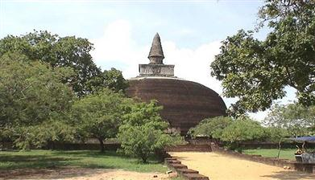
After breakfast proceed to visit Anuradhapura. It was The first capital and undoubtedly the grandest city of The ancient Ceylon. It is the home of two World Heritage Sites. Many places of historical and archaeological interest Could be visited. Sri Maha Bodhi ( Sacred Bo-Tree ) was brought as a sapling of the tree under which Prince Siddhartha attained to enlightenment and it is over 2200 years old and is the oldest historically documented tree in the world. The Brazen Palace (2nd century B.C), the 1600 stone columns you see are all that is left of a magnificent multi-storied residence for monks. Ruwanweliseya (2nd century B.C) is the most famous of all the Dagobas. It originally depicted the perfect 'bubble shape" that modern restoration has not been able to accurately reproduce. 'Samadhi' Buddha statue (4th century AD) is one of the most famous statues, depicting the Buddha in a state of 'Samadhi' or deep meditation. Isurumuniya rock temple (3rd century B.C) is well known for its rock carvings.
On completion proceed to the area of your choice and check in at hotel.
Dinner and overnight stay at Hotel as per selected category.
DAY 03 : SIGIRIYA / POLONNARUWA

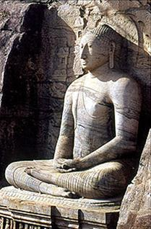
After breakfast proceed to Sigiriya and climb the 5th century Sigiriya rock fortress which is a world heritage site. Built by King Kashyapa (477-495 AD). The 'Lion Rock' is a citadel of unusual beauty rising 200 meters from the scrub jungle. The rock was the innermost stronghold of the 70 hectare fortified town. A moat, rampart, and extensive gardens including the renowned water gardens ring the base of the rock. Visit the world-renowned frescoes of the 'Heavenly Maidens' of Sigiriya, which are in a sheltered pocket of the rock approached by a spiral stairway. These frescoes are painted in earth pigments on plaster.
Afternoon visit Polonnaruwa, which was the 2nd capital city of Sri Lanka built in the 11th and 12th centuries AD, and which is a world heritage site. Here you can see the ruins of the Royal Palace, the Gal Viharaya where 4 splendid statues of the Buddha in 'Upright', 'Sedentary' and 'Recumbent' postures carved out of rock could be seen, the Audience Hall, the Lotus Bath, the statue of king Parakramabahu, and e Parakrama Samudraya - a lake built by King Parakramabahu the great. There are also monuments of famous places of worship such as the Shiva Temple, the Lankathilake, the Watadage, the Galpotha, the Kiri Vehera and the remains of a former Temple of the Tooth Relic.
Dinner and overnight stay at Hotel as per selected category.
DAY 04 : DAMBULLA or HABARANA or SIGIRIYA / DAMBULLA / MATALE / KANDY
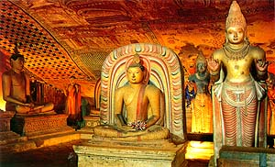
After breakfast leave for Kandy. En route visit Dambulla Rock Cave temple which was built by king Walagambahu in the 1st century B.C. and it is a World Heritage Site. It is the most impressive of Sri Lanka's cave temples. The complex of five caves with over 2000 sq. meters of painted walls and ceilings is the largest area of paintings found in the world. It contains over 150 images of the Buddha of which the largest is the colossal figure of the Buddha carved out of rock and spanning 14 meters.
Visit a spice garden in Matale to see different spices for which Sri Lanka is famous for. Here, clients could see different spices and how some of these spices are grown and processed. Witness a Cookery demonstration. On completion proceed to Kandy.
Proceed to a city tour of Kandy. Kandy was the last capital of the Sri Lankan kings and is a World Heritage Site. The name "Kandy" conjures visions of splendour and magnificence. Many of the legends, traditions and folklore are still lovingly kept alive. Drive around the Kandy Lake built by the last Sinhala king, Sri Wickrama Rajasinghe in 1798. Visit the Kandy town and bazaar, the arts and crafts centre, a gem museum and a lapidary. Also visit the Temple of the Tooth Relic in Kandy. Thereafter witness a cultural show.
Dinner and overnight stay at hotel in Kandy.
DAY 05 : KANDY / PERADENIYA / PINNAWALA / NUWARA ELIYA

After breakfast visit The Royal Botanical Garden in Peradeniya which was first built as a pleasure garden by a Sinhala king and was expanded by the British It is 147 acres in extent and provides an amazing variety of trees, plants and flowers.
Transfer from Peradeniya to Pinnawala. The Pinnawala Elephant Orphanage, established in 1975, commenced with Seven orphans. Today some of these orphans enjoy the Fortune of seeing their grandchildren born in the same location. Original objective of establishing the orphanage inclined more towards tourism, but is soon became a conservation and educational centre. With the help of local and foreign elephant experts, Pinnawela started a scientific captive - breeding programme for elephants. The free movement of the herd enhanced the chances for respective individuals of both sexes to get together and mate. The nearby river played a dominant role in this regard, and in 1984, the first baby of Pinnawela was born. The success story of Pinnawela has drawn the attention of scientists from all over the world. A considerable number of books and research articles on Pinnawela have been published in several languages. The members of the Pinnawela herd have been filmed, videoed and photographed thousands of times by professionals.
On completion leave for Nuwara Eliya. Check in at hotel.
Dinner and overnight stay at hotel in Nuwara Eliya.
DAY 06 : NUWARA ELIYA / YALA

After breakfast visit Nuwara Eliya. Nuwara Eliya, because of its invigorating mountain climate and scenery, is Sri Lankas most popular hill resort. Nuwara Eliya is also the heart of Sri Lankas tea country producing a significant share of the world s best tea. Sri Lanka s highest mountain Pidurutalagala (8282 feet) is located here. Nuwara Eliya also has one of the finest 18 hole golf courses in South Asia.
On completion leave for Yala. Check in at hotel and rest of the day at leisure.
Dinner and overnight stay at hotel as per selected category.
DAY 07 : YALA / GALLE / SELECTED BEACH RESORT
Morning proceed on an exciting jeep safari at Yala National Park. Elephant, Leopard, sloth bear, Spotted Dear, Wild Boar and sambhur. Apart from them small mammals such as Black naped hare, Grey, Ruddy & Striped necked mongoose, Grey Languor & porcupine are common small mammals. Park is also famous for its abundant bird life. Over 140 species have recorded so far within the park. Changeable Hawk Eagle, Crested serpent Eagle, Malabar pied Hornbill, Jungle fowl, painted Stork, white Ibis and Black necked Stork are commonly seen.
Thereafter transfer to your beach resort. En route visit Galle which was once the chief port of Ceylon. It is still well known for hand-made lace. You can also visit the Galle Fort (spanning 90 acres) which was originally built by the Portuguese and later extended by the Dutch in 1663. This is a World Heritage Site.
Transfer from Galle to Beach Hotel or up to Colombo.
-Tour End-

- Tour Category - Standard
 | 02 pax. | 03 pax. | 04 pax. | 05-06 pax. | 07-12 pax. | 1 pax.
Accommodation on HB & Transportation with Russian speaking guide | 565.00 | 495.00 | 450.00 | 390.00 | 360.00 | 1030.00
Entrance fees for sights | 200.00 | 191.00 | 187.00 | 185.00 | 191.00 | 227.00
Total package rate  (Accommodation + Transportation + Entrance fees) | 765.00 | 686.00 | 637.00 | 575.00 | 551.00 | 1,257.00

Single Supplement | USD 135.00
Peak period supplement (20/12/19 – 15/01/20) on DBL sharing  Peak period supplement (20/12/19 – 15/01/20) on SGL room | USD 10.00  USD 20.00

- Tour Category – Superior
 | 02 pax. | 03 pax. | 04 pax. | 05-06 pax. | 07-12 pax. | 1 pax.
Accommodation on HB & Transportation with Russian speaking guide | 635.00 | 560.00 | 490.00 | 450.00 | 420.00 | 1,160.00
Entrance fees for sights | 200.00 | 191.00 | 187.00 | 185.00 | 191.00 | 227.00
Total package rate  (Accommodation + Transportation + Entrance fees) | 835.00 | 751.00 | 677.00 | 635.00 | 611.00 | 1,387.00

Single Supplement | USD 175.00
Peak period supplement (20/12/19 – 10/01/20) on DBL sharing  Peak period supplement (20/12/19 – 10/01/20) on SGL room | USD 25.00  USD 45.00
Shoulder period supplement (11/01/20 – 15/01/20) on DBL sharing  Shoulder period supplement (11/01/20 – 15/01/20) on SGL room | USD 18.00  USD 30.00
Shoulder period supplement (16/01/20 – 31/03/20) on DBL sharing  Shoulder period supplement (16/01/20 – 31/03/20) on SGL room | USD 08.00  USD 10.00

- Tour Category – Deluxe
 | 02 pax. | 03 pax. | 04 pax. | 05-06 pax | 07-12 pax | 1 pax.
Accommodation on HB & Transportation with Russian speaking guide | 885.00 | 785.00 | 705.00 | 660.00 | 615.00 | 1640.00
Entrance fees for sights | 200.00 | 191.00 | 187.00 | 185.00 | 191.00 | 227.00
Total package rate  (Accommodation + Transportation + Entrance fees) | 1085.00 | 976.00 | 892.00 | 845.00 | 806.00 | 1867.00

Single Supplement | USD 340.00
Shoulder period supplement (01/12/19 – 20/12/19) on DBL sharing  Shoulder period supplement (01/12/19 – 20/12/19) on SGL room | USD 08.00  USD 15.00
Shoulder period supplement (21/12/19 – 10/01/20) on DBL sharing  Shoulder period supplement (21/12/19 – 10/01/20) on SGL room | USD 122.00  USD 240.00
Peak period supplement (11/01/20 – 15/01/20) on DBL sharing  Peak period supplement (11/01/20 – 15/01/20) on SGL room | USD 87.00  USD 170.00
Peak period supplement (16/01/20 – 31/01/20) on DBL sharing  Peak period supplement (16/01/20 – 31/01/20) on SGL room | USD 82.00  USD 160.00
Shoulder period supplement (01/02/20 – 28/02/20) on DBL sharing  Shoulder period supplement (01/02/20 – 28/02/20) on SGL room | USD 87.00  USD 170.00
Shoulder period supplement (01/03/20 – 31/03/20) on DBL sharing  Shoulder period supplement (01/03/20 – 31/03/20) on SGL room | USD 40.00  USD 70.00
Shoulder period supplement (01/04/20 – 30/04/20) on DBL sharing  Shoulder period supplement (01/04/20 – 30/04/20) on SGL room | USD 30.00  USD 60.00

Supplement for Beach stay transfer beyond Colombo
Colombo – Negombo - USD 28.00 per person
Colombo – Marawila - USD 34.00 per person
Trincomalee drop - USD 80.00 per person

The above prices include:
- Accommodation in standard rooms on half board basis for 6 nights from dinner on day 1 to breakfast on day 7 at hotels specified or of similar standard.
- Transportation by air-conditioned vehicle from pick up at airport to drop off in Colombo. (Departure transfer is not included)
- Services of a Russian Speaking National Guide.

Please note the Entrance fees for sights are shown separately. As per the clients’ choice, we can include it or exclude it from the package

Above prices does not include:
- Video Camera permits at Pinnawala Elephant Orphanage.
- Video Camera and Still Camera permits at the Temple of the Tooth Relic in Kandy.
- Lunch throughout the tour.
- Entrance fees to sites not specified above.
- Cost of beverage & expenses of a personal nature throughout the tour.
Hotels utilized in the tours
Town / City | Tour Category | Hotels
Colombo | Standard | Ceylon City Hotel, Colombo - www.ceyloncityhotel.com
Colombo | Superior | Fairway Colombo, Colombo - www.fairwaycolombo.com
Colombo | Deluxe | Cinnamon Lake Side, Colombo - www.cinnamonhotels.com/en/cinnamonlakesidecolombo/
Kandy | Standard | Senani Hotel, Kandy - www.oakrayhotels.com/senani-hotel/
Kandy | Superior | Hotel Topaz, Kandy - www.topaz.lk
Kandy | Deluxe | Earl’s Regency, Kandy - www.aitkenspencehotels.com/earlsregency/
Sigirya  Habarana  Dambulla | Standard | Pelwehera Village Resort, Dambulla - www.oakrayhotels.com/pelwehera-village-resort-dambulla/
Sigirya  Habarana  Dambulla | Superior | Fresco Water Villa, Sigiriya - www.oakrayhotels.com/fresco-water-villa-sigiriya/
Sigirya  Habarana  Dambulla | Deluxe | Cinnamon Lodge, Habarana - www.cinnamonhotels.com/cinnamonlodgehabarana/
Nuwara Eliya | Standard | Oak Ray Summer Hill Breeze, Nuwara Eliya - www.oakraysummerhillbreeze.com
Nuwara Eliya | Superior | Glenfall Reach, Nuwara Eliya - www.glenfallreachhotel.com
Nuwara Eliya | Deluxe | Araliya Green Hills, Nuwara Eliya - www.araliyagreenhills.com
Yala | Standard | Magampura Eco Village Resort, Yala - www.magampuraresort.com
Yala | Superior | Elephant Reach, Yala - www.elephantreach.com
Yala | Deluxe | Cinnamon Wild, Yala - www.cinnamonhotels.com/cinnamonwildyala/

NB: Standard rooms are used in all the hotels, unless specially mentioned
Seasonal supplements in each hotel (per person)

City | Hotel Name | X’mas Eve supplement (24/12/19) | New Year Eve supplement (31/12/19)
Colombo | Colombo City Hotel | - | -
Colombo | Fairview Colombo | - | USD 60.00 per room
Colombo | Cinnamon Lake Side | USD 65.00 | USD 130.00
Kandy | Senani Hotel | USD 25.00 | USD 25.00
Kandy | Hotel Topaz | USD 70.00 | USD 70.00
Kandy | The Grand Kandyan | USD 75.00 | USD 100.00
Sigiriya  Habarana  Dambulla | Hotel Wewa Addara | USD 50.00 | USD 50.00
Sigiriya  Habarana  Dambulla | Tropical Life Resort & Spa | USD 25.00 | USD 25.00
Sigiriya  Habarana  Dambulla | Cinnamon Lodge | USD 115.00 | USD 125.00
Nuwara Eliya | Oak Ray Summer Hill Breeze | USD 25.00 | USD 25.00
Nuwara Eliya | Glenfall Reach | USD 45.00 | USD 45.00
Nuwara Eliya | Araliya Green Hills | USD 60.00 | USD 60.00
Yala | Magampura Resort | USD 15.00 | USD 15.00
Yala | Elephant Reach | USD 35.00 | USD 45.00
Yala | Cinnamon Wild | USD 125.00 | USD 135.00

General Terms & Conditions
NB : The price includes governmental taxes of 1% cess, 15% VAT and 2% Nation Building Tax (applicable only to hotel rates and not DMC services).
Should there be a revision on the above taxes or introduction of NBT to DMC services or any other additional taxes levied by the government, this will be passed on to you and shall be liable for due settlement of same within the legal time frame.

Child Policy
Children below 2 years sharing parents room - Free of Charge

Children from 2-12 years sharing parents room - 30% Discount on the adult rate based on 02 pax

3rd person sharing a triple room - 10% on the per person sharing double room rate
** Please note that the extra bed in a triple room will be a foldable and rollaway bed.

Other Condition
- Optional excursions and additional services could be provided for which we will charge additionally.
- Visits to wild life parks will be at client's own risk
- Jeeps available are very basic with basic insurance cover (not comprehensive as in the case of vehicles used for tours).

Cancellation Charges:
a.) 7 days or less - 100% cancellation charge
b.) Between 8 days and 14 days - 50% cancellation charges or the equivalent of the first two days
charges depending on the programme and period of stay.
c.) Above 15 days - No cancellation charges provided no commitment or advances are
Made to 3rd parties

Hotel rules and regulations:
The official check-in time at all hotels will be 1200hrs.
The official check-out time at all hotels will be 1100hrs.
Cancellation policy will be applicable for any reduction of rooms after the release period.

Visas:
All countries should apply for visa online through www.eta.gov.lk

Airport Tax:
Cost of Airport tax is included to the flight ticket. However, this could differ for Charter flights.

